

**Department of Informatics University of Leicester**

**CO7201 Individual Project**

**Final Report**

**Generations Connect: A Collaborative Family History Platform**

**Naga Babu Velisala**

**nbv3@student.le.ac.uk**

239055440

**Project Supervisor: Ms Martina Palusa**

**Principle Marker: Dr Newman Lau**

**Word Count: 11287**

**[16-05-2025]**

|  |
| --- |
| **ABSTRACT**  This site allows families to preserve and share their legacy via an integrated interface that supports collaborative creation and editing of family trees, defines relationships, and manages profile photos; uncovers genetic details through ordering DNA kits and uploading results; records, shares, and organizes oral stories; schedules and tracks important family occasions; maps ancestral places on an interactive world map; and customizes personal and security settings—all aimed at encouraging intergenerational storytelling, synchronized collaboration, and long-lasting preservation of familial heritage.  **DECLARATION**  All sentences or passages quoted in this report, or computer code of any form whatsoever used and/or submitted at any stages, which are taken from other people’s work have been specifically acknowledged by clear citation of the source, specifying author, work, date and page(s). Any part of my own written work, or software coding, which is substantially based upon other people’s work, is duly accompanied by clear citation of the source, specifying author, work, date and page(s). I understand that failure to do this amounts to plagiarism and will be considered grounds for failure in this module and the degree examination as a whole.  Name: Naga Babu Velisala  Date: 16-05-2025 |

**TABLE OF CONTENTS**

1. **INTRODUCTION** 1

1.1 AIM AND OBJECTIVES 1

1.2 CHALLENGES 1

1.3 RISK ASSESSMENT 2

1.4 BACKGROUND RESEARCH 2

**2. REQUIREMENTS** 3

2.1 HIGH-LEVEL REQUIREMENTS 3

2.1.1 FAMILY TREE VISUALISATION 3

2.1.3 DNA MANAGEMENT 3

2.1.4 EVENT SCHEDULING 4

2.2 DETAILED REQUIREMENTS 4

2.2.1 ESSENTIAL REQUIREMENTS 4

2.2.2 RECOMMENDED REQUIREMENTS 5

2.2.3 OPTIONAL REQUIREMENTS 5

**3. TECHNICAL SPECIFICATIONS** 6

**4. METHODOLOGY** 8

4.1 APPROACH, CLIENT-SERVER ARCHITECTURE 9

4.11 DEVELOPMENT STAGE 9

4.12 TESTING PHASE 9

**5. DESIGN** 10

5.1 ARCHITECTURE DIAGRAM 10

5.2 SEQUENCE DIAGRAM 11

5.3 CLASS DIAGRAM 12

5.4 DATABASE DESIGN 13

5.41 DATABASE MANAGEMENT 15

**6. IMPLEMENTATION** 16

**6.1 FRONTEND DEVELOPMENT 17**

6.1.1 DASHBOARD SNIPPET...............................................................................................18

6.1.2 FAMILY TREE NODES SNIPPET…………….…………….......................................20

6.1.3 WORLD MAP SNIPPET......................................................................................22

6.1.4 DNA KIT MANAGEMENT SNIPPET…..…*.....................................................*.........23

6.1.5 VOICE STORIES SNIPPETS……….…..…*...........................................................*......23

6.1.6 FAMILY EVENTS SNIPPETS……….…..…*........................................................*......24

**6.2 BACKEND DEVELOPMENT 25**

6.2.1 SYTEM ARCHITECTURE OVERVIEW……….…..…*........................................*......26

6.2.2 CONFIGURATION & SECURITY……..……….…..…*........................................*......26

6.2.3 CONTROLLER LAYER………….……..……….…..…*........................................*......27

6.2.4 SERVICE LAYER………………...……..……….…..…*........................................*......27

6.2.5 PERSISTENCE & ENTITIES………….….…….…..…*........................................*......28

6.2.6 ROUTES AND FUNCTIONS....................................................................................... 29

6.3 API INTEGRATION 30

6.31 AWS COGNITO IDENTITY PROVIDER……………………………………………30

6.32 GOOGLE GEOCODING API………………………………………………………….31

6.33 STRIPE CHECKOUT API……………………………………………………………..31

6.4 PLUGINS AND LIBRARIES 32

6.5 BUILD AND RUN THE APPLICATION 33

**7. TESTING** 34

**8. FUTURE ENHANCEMENTS** 38

**9. SUMMARY** 43

**10. CONCLUSION** 44

**11.REFERENCES** 45

# 1. Introduction

## Aim and Objectives

The Family Tree Application is an extensive, user-pleasant platform geared toward strengthening own circle of relatives hyperlinks via the powerful documentation, enrichment, and maintenance of genealogical heritage. The platform gives an modern gadget that empowers humans of various a long time and technological competency to create elaborate, multigenerational own circle of relatives trees, upload non-public reminiscences, and document essential activities in narrative modes. With the usage of user-pleasant modifying tools, dynamic mapping for ancestral migration paths, and multimedia skills for the insertion of photographs and audio stories, the utility transforms traditional genealogical facts to a dynamic, residing series of reminiscences and heritage. This project aims to develop a collaborative family history platform that will enable users to document, share, and explore their ancestry. The developed platform will provide an interactive and user-friendly experience for managing family records, enhancing historical data visualisation, and helping engage through advanced features such as duplicate detection, event tracking, and multimedia integration. It promotes ongoing interaction with the exchange of referrals and customized settings, thus enabling the growth of family networks while maintaining their information from generation to generation. The modularity maximizes the extensibility potential, enabling future additions of features like shared notes, timeline exports, or synchronization with other repositories without sacrificing usability or performance under increasing complexity or tree sizes.

* Facilitate the generation of dynamic family trees using drag-and-drop editing features, in addition to real-time relationship visualization.
* Enable the integration and safe storage of user-uploaded media, such as photos, audio, and documents, to enhance individual family profiles.
* Provide based workflows for occasion planning, scheduling, and ancient milestone recording.
* Create geospatial visualizations of ancestral lineages and movements to enable contextual analysis.
* Enable personalized user profiles with settings for privacy, notifications, and referral sharing.

## **Challenges:**

* Managing complex family data handling of large, interdependent family data is a significant challenge. Dealing with the intricacies involved in large, interdependent families requires the representation of many relations through a well-designed interface supported by thorough data handling techniques to avoid user confusion. Enabling user navigation and readability in the face of increasing information complexity requires careful planning and execution.
* Providing Seamless Media Integration the collection of different media types, including images, audio files, and text documents, augments the end-user experience but at the same time raises storage, retrieval, and accessibility issues. To ensure timely and precise access to media over diverse network environments and devices, the use of sophisticated media management techniques, optimization techniques, and intuitive interfaces is imperative.
* The use of geographic visualizations to show ancestral places and migration routes poses the problem of converting historically meaningful addresses to specific geographic coordinates. High accuracy is required, with inaccurate or imprecise coordinates potentially reducing the credibility of the application and undermining the trust of users. Addressing this problem requires the use of strong geocoding techniques, enabling manual corrections, and providing easy-to-use fallback options for enhancing the effectiveness and usefulness of map visualizations.

## **Risk Assessment:**

**Risk Factor: Performance slowdown with large datasets**

**Action:** Implement on-call for loading strategies for massive statistics, optimize rendering performance, and strategically cache statistics to keep clean utility responsiveness.

**Risk Factor: Data conflicts from simultaneous edits**

**Action:** Employ model manipulate and constructive locking, virtually tell customers approximately conflicting edits, and offer intuitive warfare decision workflows.

**Risk Factor: Low adoption among non-technical users**

**Action:** Develop user-pleasant tutorials, offer contextual assist during the platform, and hold accessible, responsive customer service to help much less skilled users.

**Risk Factor: Limited functionality offline**

**Action:** Enable nearby caching of crucial functions and latest activities, and facilitate history synchronization while connectivity is restored, making sure non-stop functionality.

**1.4 Background Research**

Family records studies have gone beyond paper records to virtual interactive studies which highlights person involvement and storytelling. According to recent studies, the multimedia narratives – that is incorporating photos, voice recordings, and contextual maps – significantly increase person memory and attachment. Graph-based models are recommended due to the possibility to represent complex relationships and assist fast migration across generations. By usability studies, there is a desire for clean visible hierarchies, undo/redo, and conflict-recognition in the collaborative enhancing environments. Additionally, tracing the ancestral actions enriches old scenario, while, properly customised dashboards and referral packages increase network involvement and guarantee lasting lifetime of own circle of relatives archives.

ANCESTRY(by author John Sittner) serve as examples of successful fusions of elements such as family-tree-building, multimedia-storytelling, and family history discovering. Ancestry.com enables users to delve into genealogical search through an easy to use interface and masses of historical records as well as user-generated content, which shows the relevance and efficacy of multimedia stories and community functions to enhance powerful emotional ties and prolonged participation by users.

**2 Requirements**

## **2.1 High-Level Requirements**

### 2.1.1 Family Tree Visualization:

It Provides an interactive and accessible platform that facilitates the setup, modification, and exploration of complex family relationships. This feature allows users to easily see different generations, accurately state relationships, and manage vast amounts of personal details with a view of encouraging active participation and extensive recording of family stories. Users have the ability to collectively add to, edit, and publish their family trees in real time, thus encouraging interactivity. Further, the platform ensures a clear insight into the dynamics of relations, allowing individuals to understand and navigate relationships with ease, thus greatly enhancing their experience and comprehension of family arrangements.

**2.1.2 DNA Kit Management:**

Provide access to genetic information by providing them with the ability to service, select and purchase DNA testing systems directly from the platform. Users can upload their genetic information safely, and therefore, family profiles will get more enriched in terms of genetic details, thus making the genealogical research conducted by them more complete and accurate. This provides an opportunity to examine the genetic traits and reports on one’s ancestors while at the same time lets the members of the family cooperate in researching the genetic background. A lot of vigilance is also placed on the measures of privacy and protection of the data like the personal genetics details are kept and implemented securely hence giving the users confidence.

**2.1.3 Event Scheduling and Tracking:**

Offer extensive resources for creating, adjusting, and managing family events, such as reunions, birthdays, and anniversaries. The portal ensures efficient organization, event notifications, and collaborative participation that enables families to schedule and celebrate milestone events with ease. Users can manage guest lists, send invitations, and create customized reminders to enhance event organization. In addition, the site offers the functionality of comprehensive event record keeping and media uploads for participants to post memories and special moments, thus enriching the shared family event experience.

## **2.2 Detailed Requirements:**

### 2.2.1 Essential Requirements:

**User Authentication & Role Management :**

* Users can register, log in, and manage profiles.
* Supports secure password management and profile customization options.
* Role-based access control (Admin, Contributor, Viewer) to define editing and viewing permissions.

**Family Tree Management**

* Users can create, update, and delete family members.
* Relationships (parent-child, spouse, siblings) are accurately managed.
* Enables visualization of complex family relationships through clear and intuitive interfaces.

**DNA Data Integration**

* Users can browse, select, purchase, and securely upload DNA data.
* Integration of genetic insights into family profiles for enriched genealogical research.

**Event Tracking & Interactive Timeline**

* Users can document and manage significant family events (births, marriages, deaths, migrations).
* An interactive timeline visualization enhances historical data exploration.
* Advanced event search and filtering capabilities.
* Allows sharing of events with other family members and provides reminder notifications.

**Duplicate Detection & Merging System**

* Automated detection of duplicate family members.
* Users can review and merge duplicate entries based on suggested matches.
* Provides detailed comparison views to assist users in accurately merging data.

**Backup & Restore Functionality**

* Users can save and restore snapshots of their family tree.
* Ensures data integrity and recovery in case of loss or errors.
* Offers automated backup scheduling to regularly secure family data without manual intervention.

### 2.2.2 Recommended Requirements

**User Comments & Notes on Profiles**

* Users can leave comments or notes on family member profiles for collaborative documentation.
* Comments support threaded conversations to facilitate detailed discussions.
* Users can tag specific family members within comments to ensure visibility and context.

**Notifications & Activity Log**

* Tracks changes made to the family tree (e.g., “New member added by [User]”).
* Users receive notifications about updates to their family records.
* Provides customization options for notification types and frequency to enhance user experience.

**World Map Integration**

* Users can visualize and explore family ancestral locations on an interactive global map.
* Historical migration paths are plotted dynamically based on entered family events.
* Interactive map markers include detailed pop-ups with family member information and related historical events.

### 2.2.3 Optional Requirements

**Voice Recording for Family Stories**

* Users can record and store voice clips of family members sharing personal histories.
* Recordings can be organized by family member and tagged with relevant metadata for easy retrieval.
* Users have the ability to share voice recordings securely with selected family members.
* Integration of playback controls within family profiles provides easy access to audio stories.

**Testimonial Feedback**

* All participants are allowed to post their individual experiences on the platform.Testimonials can include text and media attachments for richer feedback.
* Publicly endorsed reviews benefit potential users in the process of understanding the value of the platform.
* Administrators can review, approve, or decline submitted testimonials to maintain content quality.

**Social Media Integration**

* Enables users to share significant family milestones directly to their social media accounts.
* Users can import contacts or invite family members to join via popular social media platforms.
* Supports sharing of specific family tree views or stories with privacy controls to ensure data security.
* Allows synchronization of event notifications and updates with user-linked social media calendars.

# 3. Technical Specifications

|  |  |  |  |
| --- | --- | --- | --- |
| **Components** | | **Technologies & Version** | **Description** |
| Frontend | Languages | HTML 5  CSS 3  JavaScript ES6 | Markup language for structuring web content.  For designing the look and formatting of a website. Scripting language for building dynamic web content. |
|  | Frameworks and  Libraries | Next.js 15.2.2 / React 19.0.0  React Router | Component-based UI framework with SSR/SSG and file-based routing.  Tool for managing navigation in React app. |
|  |  | Axios  AWS Cognito | Client for making HTTP requests to APIs.  Cloud-hosted user sign-in/up and session (JWT) management. |
| Backend | Languages  Runtime  Environment  Frameworks | Java 17+  OpenJDK 17 (JRE) Spring Boot Embedded Tomcat Docker 20.10+  Spring Boot (3.x) | LTS version with modern language features.  Runs on a Java 17 JVM with Spring Boot’s bundled Tomcat servlet container. Packaged as a Docker image (Docker 20.10+).  Java framework for building microservices and RESTful APIs. |
|  | Libraries | Spring Security OAuth2 Resource  jjwt (0.11.x),  AWS SDK for Java v2 (S3, Cognito Identity, SQS) (2.x) | Secures endpoints with JWT/OAuth2, handles token validation and authentication flows.  Programmatic access to S3 buckets, Cognito user pools, and message queues. |
| APIs | | Google Maps API | Autocomplete address input, render interactive map. |
|  | | Stripe API | Create checkout session when “Buy Now” is clicked. |
| Database | | Neo4j (Graph Database) | Store users, family-member nodes & relationships (parent/child, spouse). |
|  | |  | **Node labels**: User, Event, Story  **Relationships**: PARENT_OF, SPOUSE_OF, CREATED_EVENT. **Constraints**: :User(id) UNIQU E. |
| Tools | Unit & Integration | Jest   |  | | --- | | 29.7.0 |  |  | | --- | |  | | Run JS/TS unit & integration tests. |
|  | Testing | Postman | Tool for testing APIs. |
| Operating System | | Windows 11 | Operating system for development. |
| Version Control | | Git | Version control system for managing code changes. |

# 

# 4. Methodology

The development of the Family Tree Web Application took a feature-driven and modular direction whereby the target was to provide an experience based on users’ requirements. The project started with a requirements analysis and user journey mapping in order to understand where the critical interactions and processes are. Iterative design sessions allowed for structuring of the user interface fragment with a view towards clarification and improvement of the accessibility subsequent to the gradual introduction of features in the front-end and back-end. Functionality was developed and tested in turn to make sure that each module could run independently and further integrate with the whole system. Periodic feedback engagements with the users informed the development, data modeling strategies were employed to accurately define real familial arrangements and relationships. During development, this platform was stable, responsive, and user friendly because of continuous testing (unit, integration and usability testing).

## **4.1 Approach**

The approach used in the development of the Family Tree Management System focused on the aspects of modularity, scalability, and user-centred design. Requirements were initially gathered and examined for the objectives of identifying significant functionalities such as CRUD operations on family members, event recording, DNA uploads, and interactive mapping functionalities. Frontend development optimized the usage of React.js along with the Next.js framework for seamless page routing, allowing hot reloading and server-side rendering. User interface components were coded using Bootstrap, while the implementations of secure form handling and media handling integrations used the likes of React Hook Form and Node file handlers.

Our approach was centered on a modular architecture that separated front-end elements from back-end services to allow for parallel development and independent testing. Incremental deployment of features was supported by integration tests that validated end-to-end functionality and performance metrics that guided optimization. Automated pipelines were used for the build, test, and deployment of updates, thus promoting rapid delivery while maintaining stability. User feedback channels were important, with usability sessions informing enhancements to accessibility and overall user experience.

**4.11 Development Phase**

Within the Development Phase, the work was structured in an organized series of focused sprints, one for each feature set (for example, changes to the family tree, mapping integration, DNA workflow, and event organization). Scope and acceptance criteria were determined during sprint planning, and daily stand-up meetings allowed for team interaction. Code review and constant integration guaranteed high quality and allowed for quick detection of faults. Parallel development on both front-end and back-end pieces allowed for concurrent progress, which was then integrated and shown within a staging environment for initial feedback.

**4.12 Testing Phase**

The Testing Phase covered unit testing, integration testing, and user acceptance testing to validate the functionality of individual modules and end-to-end workflows. Automatic test suites ran for every commit through the CI/CD pipeline, enabling quick regression detection. Targeted usability testing, using representative users, uncovered edge-case workflows and accessibility issues, which were addressed through systematic remediation. Performance metrics—loading capacity and displaying large family trees—guaranteed system responsiveness, while security audits and permission checks ensured compliance with data protective requirements. Continuous monitoring of coverage and issue trends guided eleventh-hour changes before release.

## **Client-Server Architecture**

The Family Tree Management System is based on a Client-Server Architecture that separates the roles of user interface functionality and data processing tasks. The client side, built using React.js and Next.js, serves as the main interface for user interaction, including activities such as displaying family trees, managing events, uploading DNA files, and displaying maps. User requests are made using event handlers or Axios API calls, which are then routed to the backend system. Functionality that demands dynamic interaction, such as the Google Maps API and form submissions, employ asynchronous data fetching methods to foster a responsive user experience. Frontend authentication is tightly coupled with AWS Cognito, which provides secure tokens for subsequent API interactions, ensuring that sensitive operations can only be performed by authorized users.

On the backend side, a Spring Boot backend is used as the core processing system. It offers a set of RESTful APIs responsible for handling frontend-originating requests such as user registration, storing data, filtering search, and file upload. Neo4j serves as the central database, efficiently portraying family member relationship hierarchies. Authentication workflows and the handling of access based on roles is dealt with using Spring Security and JWT, and the media files are stored securely in AWS S3. Further, the architecture is augmented with the added facility of handling asynchronous non-blocking tasks and a scale-up capable design adhering to microservice-compatible patterns, thus making the system stable, secure, and flexible for future upgrades.

# 5. Design

## **5.1 Architecture Diagram**

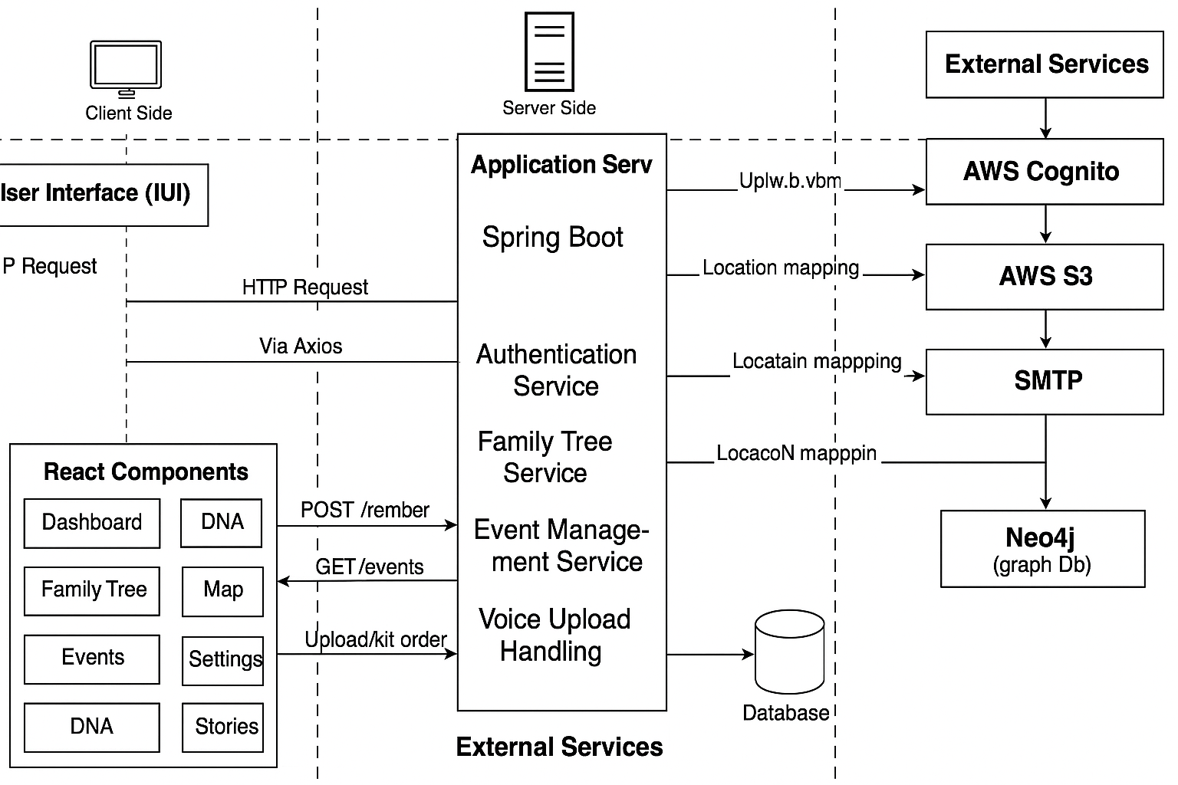

*Figure 1 : Architecture Diagram*

The above architecture diagram illustrates a client-server architecture that involves a frontend built on React, backend APIs with Spring Boot, and cloud services from AWS. The frontend is responsible for providing a responsive user interface while supporting interactions like searching, authentication, voice recording, and analytics. User interface requests are directed via the backend API, which acts as a middle layer between the user-facing application and the core services. Authentication is carried out using AWS Cognito, thus providing secure access, while family tree data is managed by dedicated services in the backend. Every action, be it logging in, accessing the family tree, or posting voice narrations, is carried out by separate backend services and routed to the respective storage or database system.

At the backend, the Spring Boot APIs communicate with various cloud services for data processing and management. AWS S3 is used as the vehicle for media storage, such as voice recordings, while Neo4j is used as the graph database that structures hierarchical familial relationships. Duplication detection and indexing mechanisms are used within the architecture to maintain data integrity and improve performance. Service requests are authenticated and filtered through layered services, thus promoting a clear separation of concerns and bolstering security protocols.

## **5.2 Sequence Diagram**

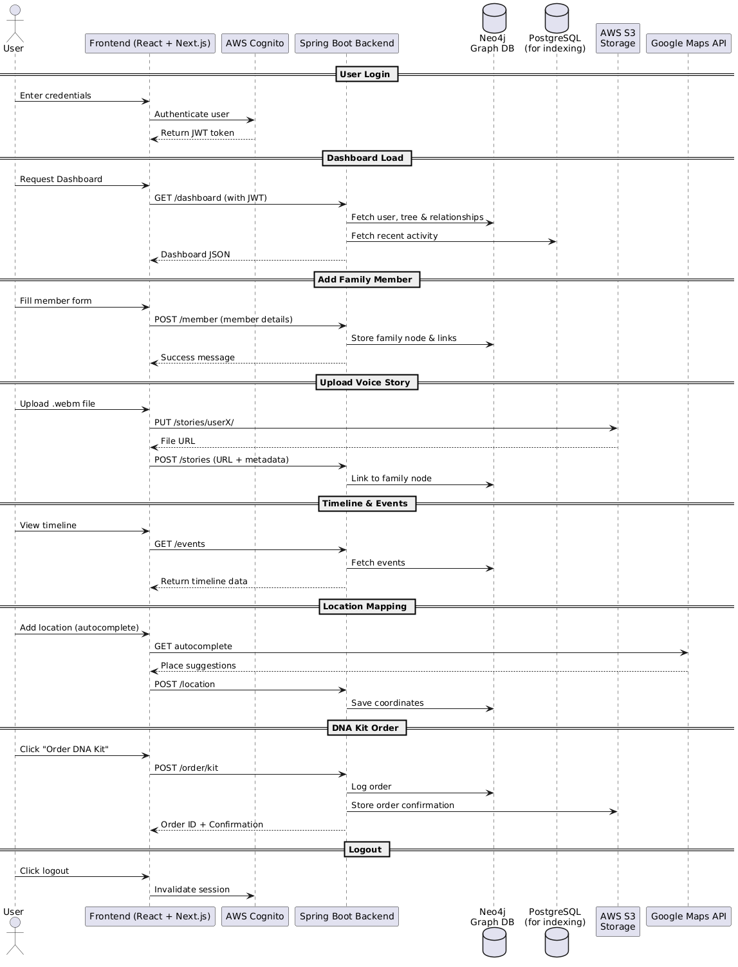

*Figure 2 : Sequence Diagram*

The above figure 2 diagram indicates the entire pattern of the user interaction in the application of the Family Tree and includes the complete process from the very initial login to the final logout. The process begins by when the user submits his/her credentials which are further verified with the use of AWS Cognito thereby creating a JWT token which in turn will be used for validating the latter requests. Upon connecting to the dashboard, a GET request for the JWT is made to the Spring Boot backend as well and it fetches user profile, family relations from Neo4j and recent activity history and returns back the data as a JSON payload. Adding a family member consists in sending form data using a POST request and adding a new node in the Neo4j with respective relationship connections to the backend. Uploading a .webm voice story is done in two different steps… first, the file is uploaded to AWS S3 and then information about the metadata and the reference URL is presented so as to connect it to the particular family member.

The depicted supporting operations in the sequence diagram denote critical functionalities, like those that allow visualizing timeline, mapping location, ordering a DNA kit, and logging out in a safe session. The timeline events are simply picked up by a GET request on PostgreSQL the database used in this regard to covet efficient indexing and filtration. The location mapping action takes advantage of the autocomplete feature of the Google Maps API to geolocate and stores the values in the form of POST requests. The initiation of ordering of DNA kit is done via POST request and after the documented storage by the backend, a receipt is sent to the frontend. Lastly, the logging out process employs the service of Cognito which cancels the session, and the user’s token. Such sequence pattern precisely marks the asynchronous communication that is safe between the user, frontend, backend, and the onboard cloud services.

## **5.3 Class Diagram**

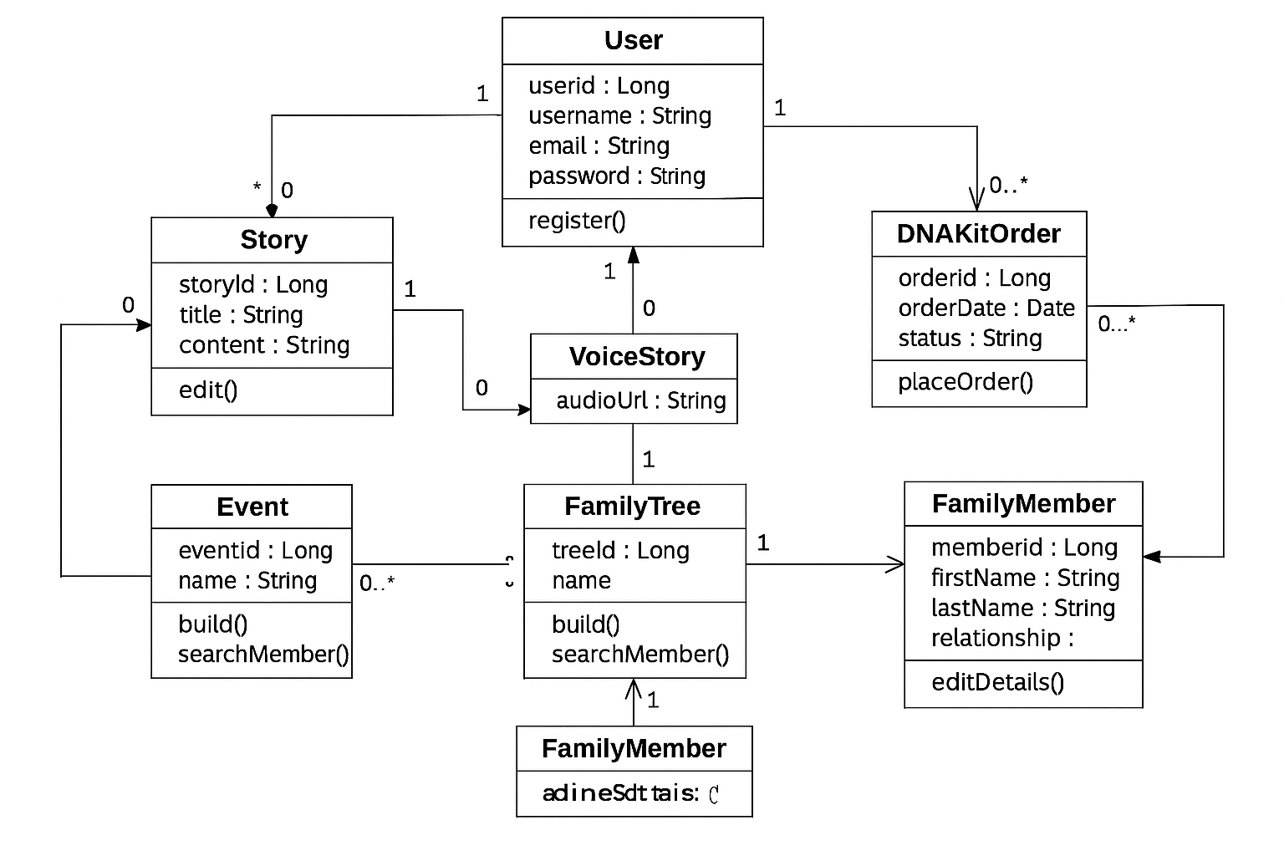

*Figure 3: Class Diagram*

The Class diagram increasingly defines the main data structures and interrelations that are present in the family tree platform. In the center of the system is the class for the User, which contains both personal details as well as the authentication details along with a collection of FamilyMember objects which represent the family relations. Every FamilyMember instance is able to model both parent-child and spousal relationships, meaning that it can support dynamic graph-based representation of a lineage. Events class gives significant familial events like births, marriages and deaths and reference pointers to the related members. The audio stories created by users have their place in the Story class that contains such metadata as timestamps and links of media. The classes that will handle the DNA kit ordering purchases that contain information that consists of shipping status and any associated users will be the Order class. All in all these classes make up a modular framework that is capable of being integrated with backend facilities therefore facilitating the storage of data using Neo4j.

**5.4 Database Design**

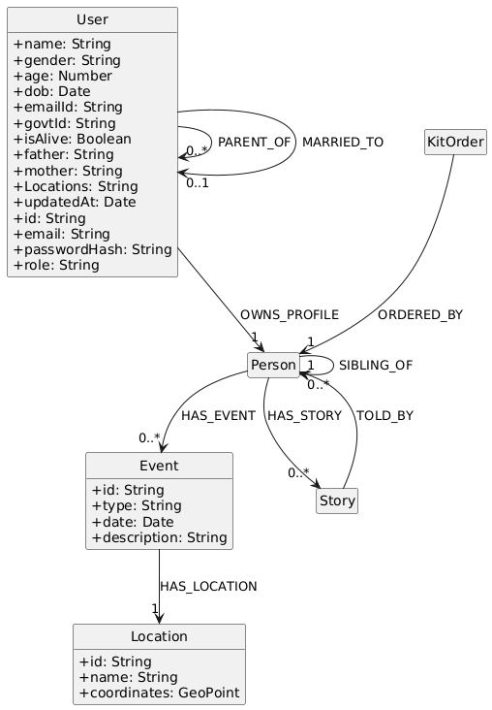

*Figure 4 : Database for Family Tree*

Class diagram(Fig.4) is an powerful manner of describing information version and courting shape of Neo4j-primarily based totally own circle of relatives tree app. Neo4j is a graph database, that is beneficial if interconnected information which includes own circle of relatives, stories, and occasions matter. Here, statistics is saved withinside the nodes (entities), and the relationships (edges). Every User node has a person`s non-public statistics like name, gender, age and identifiers which includes email, authorities ID and so on. This User will have one or extra Person profiles, which which correspond to real individuals of the own circle of relatives tree. The PARENT_OF, MARRIED_TO and SIBLING_OF relationships well constitute real-global connections among own circle of relatives individuals.

**5.41 Database Management**

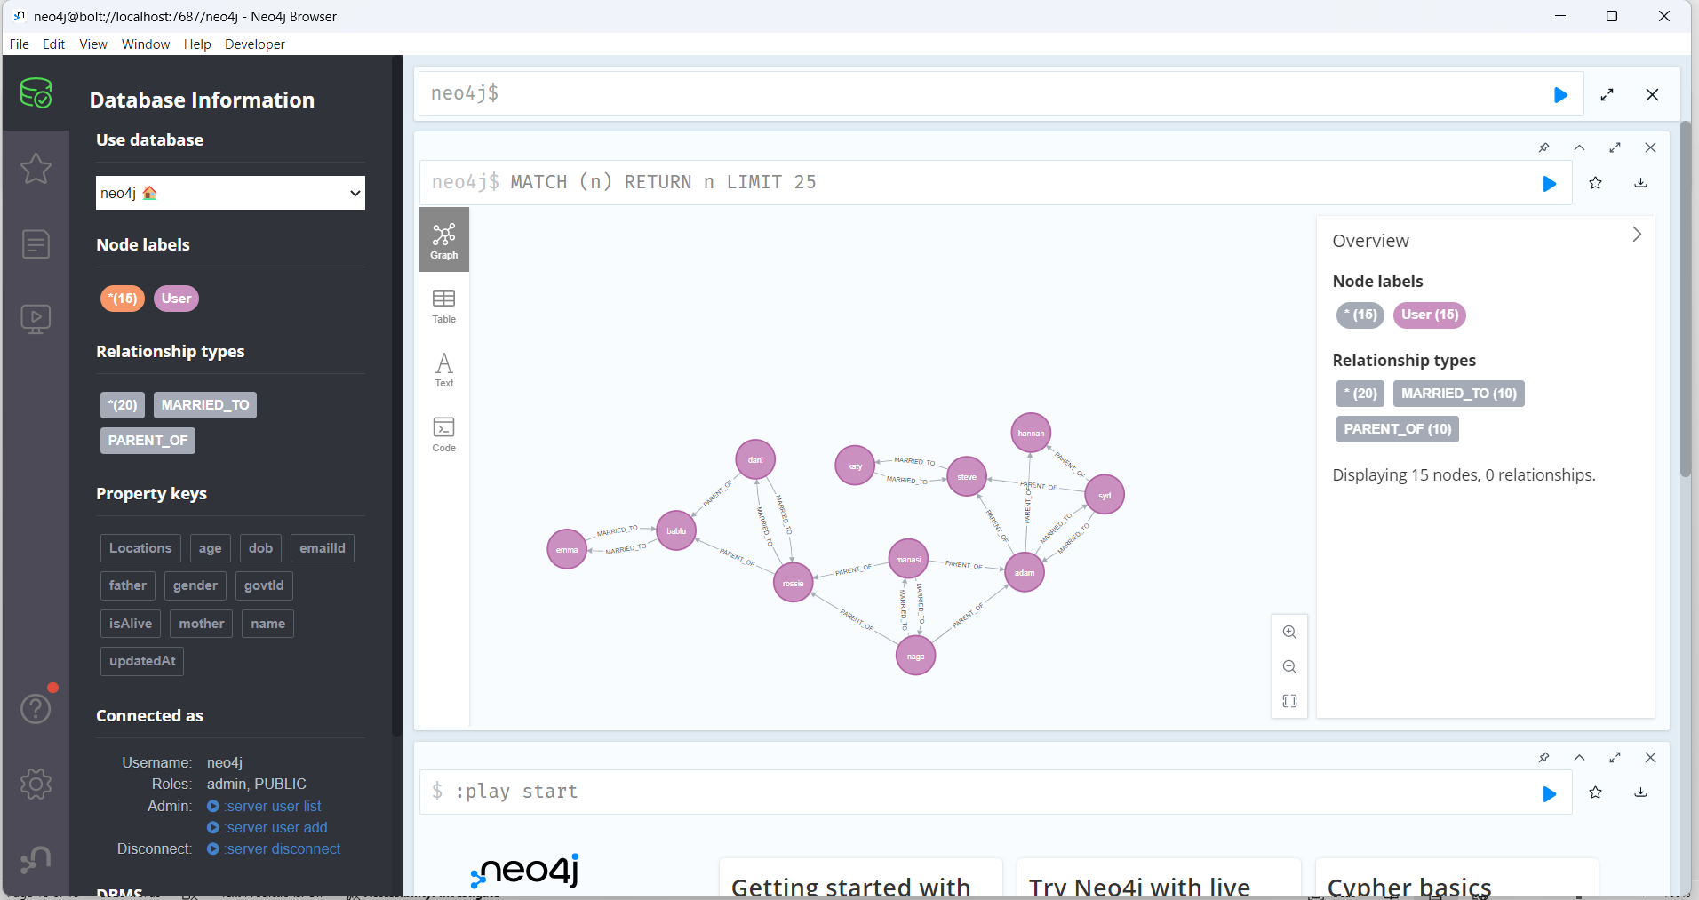

*Figure 5 : Database Visualisation*

For the purposes of information visualization, Neo4j provides a bendy interface from which information can be viewed in many thereof. In the graph view entities which consists of User, Person, Event, Story, and Location are nodes where strains are relationships. This helps while visually referring connections and traversals. At the same time, the same information is provided in the form of a table for filtering and sorting for the desktop view presentation, and the text view presents the developers with unaltered Cypher output. This creates an a chance for every non technical customers and builders to acquire get admission to to the records seamlessly in order that visible exploration in addition to backend driven analytics amongst other issues can be enabled.

Behind the scenes, the Spring Boot application communicates with Neo4j through Spring Data Neo4j – a framework that enables mapping of objects in Java (entities) to nodes and relations in the graph. Upon registration or addition of family members, REST API calls are made to back-end from which Axios sends calls from the frontend (React) which translates to Cypher queries to store the data into Neo4j. For instance, if a user creates a Story, it is related to a Person through relationship has_story and when a new event is being created, it’s related using has_event. This architecture supports rich queryable paths such as “show all stories told by or about a specific person” taking advantage of Neo4j traversal abilities.

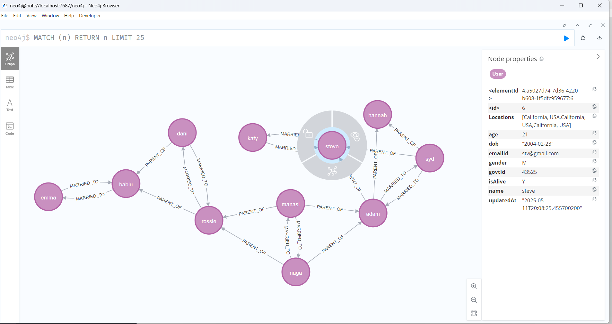

*Figure 6 : Database Node Details*

The Figure 6 highlights one of the maximum effective visible skills of Neo4j—interactive graph exploration. By clicking on a person`s node (on this case, "steve"), specific homes together with name, age, email, authorities ID, and location are displayed in a facet panel, permitting customers to research man or woman profiles easily. This enriched interface aids in brief verification and debugging through displaying each the data and its relationships in actual time. The connecting strains labeled "MARRIED_TO" and "PARENT_OF" truely outline familial relationships, and the route of arrows permits hint the shape of lineage or connection. Names showed proper now on nodes make the visualization intuitive and human-readable, mainly for complicated very circle of relatives trees. This diploma of element and interactivity empowers each builders and end-customers to govern and recognize huge volumes of dating data efficiently.

Other than strength in terms of records modelling and visualization; Neo4j also has green querying and indexing which supports performance while executing complex data retrieval activities. For example, in a relatively short time, the customers can obtain all the family belonging to a certain technology or find duplicated profiles primarily by using dating styles and node properties. Any type of node (for example, GovtId), to perform fast retrievals. The communication to Spring Boot backend is handled via the Bolt protocol, so keeping stable and periodic latency communicational. Further, the backend can cause analytics or notifications in response to a records update.

# 6 Implementation

## **6.1 Frontend Development**

All the major functions, including authentication, navigating the dashboard, visualizing trees, using maps, DNA kits, scheduling events, making voice stories, and managing user settings, are organized into different folders within src/app. Navigation bars, protected routes, and API clients are all organized in the common components/ and utils/ section to encourage their use in several areas. To prevent collisions and permit theming, style for each component is written using a mix of CSS modules and inline styles. Because of Next.js’s file-based approach, routing enables clean URLs and smooth transitions between web pages.

**6.1.1 Dashboard Page Snippet**

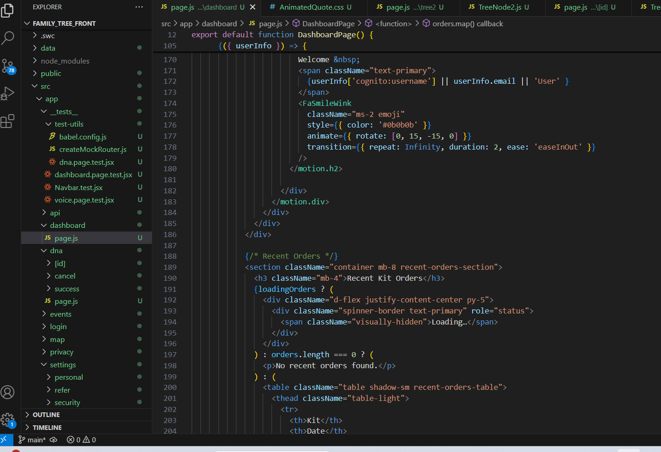

*Figure 7 : Code screenshot of Dashboard*

The provided snippet utilizes data retrieval, management, and interactive animation techniques to create an overall summary. A route wrapper is first used to limit content accessibility based on the respective permissions. Next, the useEffect hook is used to retrieve information on users, what kits they have purchased and customers' feedback on those kits, from the API. The AnimatedQuote component displays helpful family insights for users, and a progress bar visually displays the progression of the user’s profile status. This part integrates the collected data into a dynamic table, which displays the order date,

the purchased kit, its status, and edit and update links for it. Below this, a carousel is used to display testimonials, and it gives visitors a chance to provide their feedback accordingly. The use of animation through the implementation of Framer Motion, coupled with the use of conditionals, helps to manage the phase of loading, hence making the website experience smooth and cohesive.

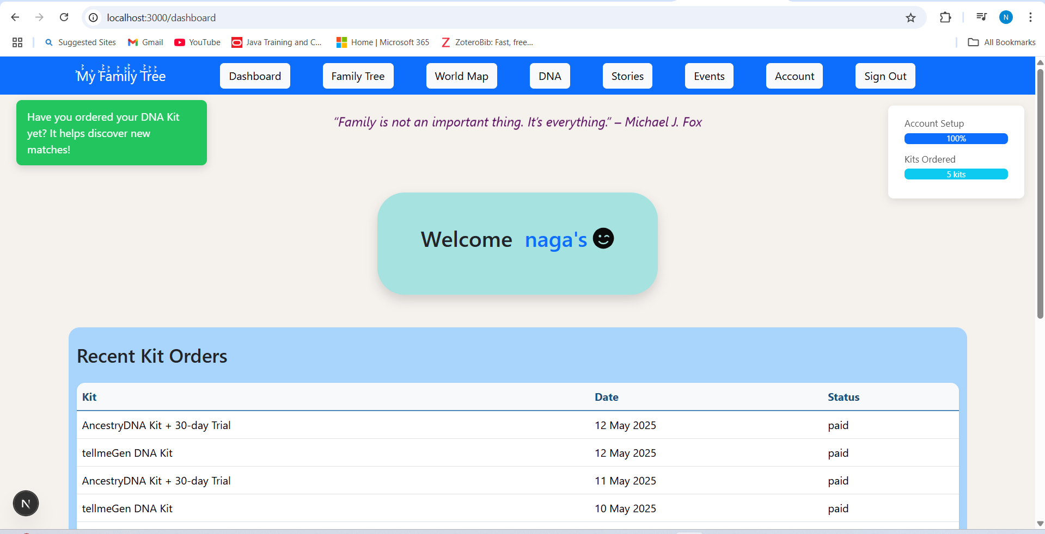

*Figure 8 : UI screenshot of Dashboard page*

When you come to the Login page, you’ll get a friendly greeting and interesting facts along with access to dark-mode settings and authentication. Once the identity process is done, the Dashboard(figure 8) shows a review tailored to the user: You can check how far setup is with the progress bar, review recent orders using the table, see brief tips in real time, and look through a carousel of user feedback. Users can click on special links to use important features, and a regular navigation bar helps them move easily between pages.

**6.1.2 Family Tree Node Snippet**

The below(figure 9) snap component works by rendering each family member as a card, and each card contains their profile photo and any photos of their spouse or children. Essentially, it adds React’s useState and useEffect hooks as well as the downloadProfile function to get images from S3. It loads the main picture inside the useEffect, then brings in the spouse’s image, and pre-loads all the photos of the children, so everything remains smooth when more nodes are loaded. It saves the local state of profileImages so that each card changes automatically, and in case an image is missing, it is substituted with a placeholder. Why add card for person object with icons and handlers that open the TreeModal dialog for editing or adding relations.

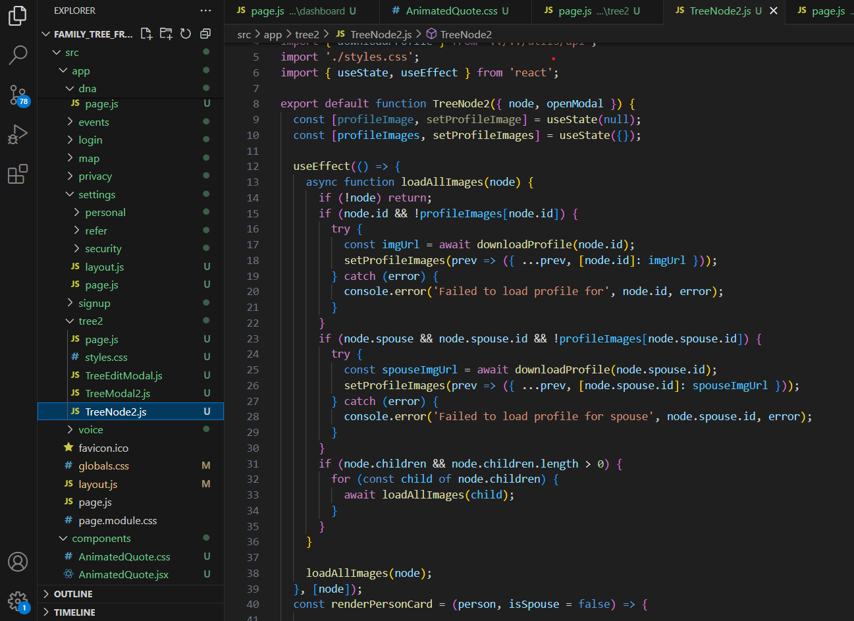

*Figure 9 : Code screenshot of Tree Model*

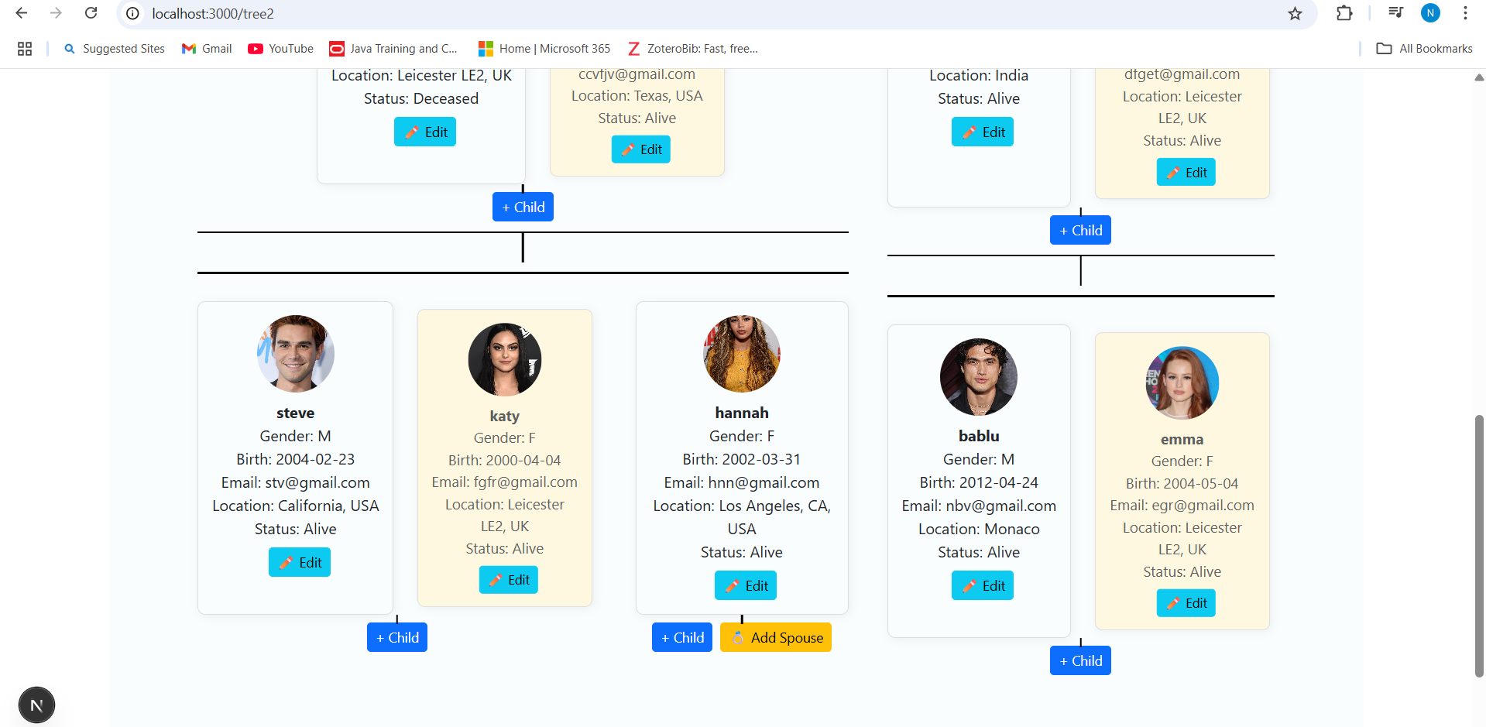

*Figure 10 : Code screenshot of Tree Model*

Here, the figure 10 clearly shows users have the ability to manage every message that is related to their family line. The tree node shows each generation by a hierarchical tree layout, which can be collapsed and expanded for different branches, and the right-click context menu allows adding children, spouses, or making changes. Entry fields for the modal dialog make it easy to enter one’s personal information, current location, or relationship status, and directly upload and attach images. Navigation buttons give users the power to explore sets of relatives or view the page of a particular family member. The building block of the family-tree UI by recursively rendering each person as a card that includes their profile picture, name, and relations. The following screenshot shows parent and spouse cards laid out next to each other, with children listed in a flex container below, all linked by obvious CSS lines. Behind the scenes, a useEffect hook is used to pre-load the current node's, its spouse's, and its descendants' images to avoid flickering when expanding a branch. The interactive cards allow the opening of modals for adding or editing a person, making it easy for users to manage their family tree.

**6.1.3 World Map Snippet**

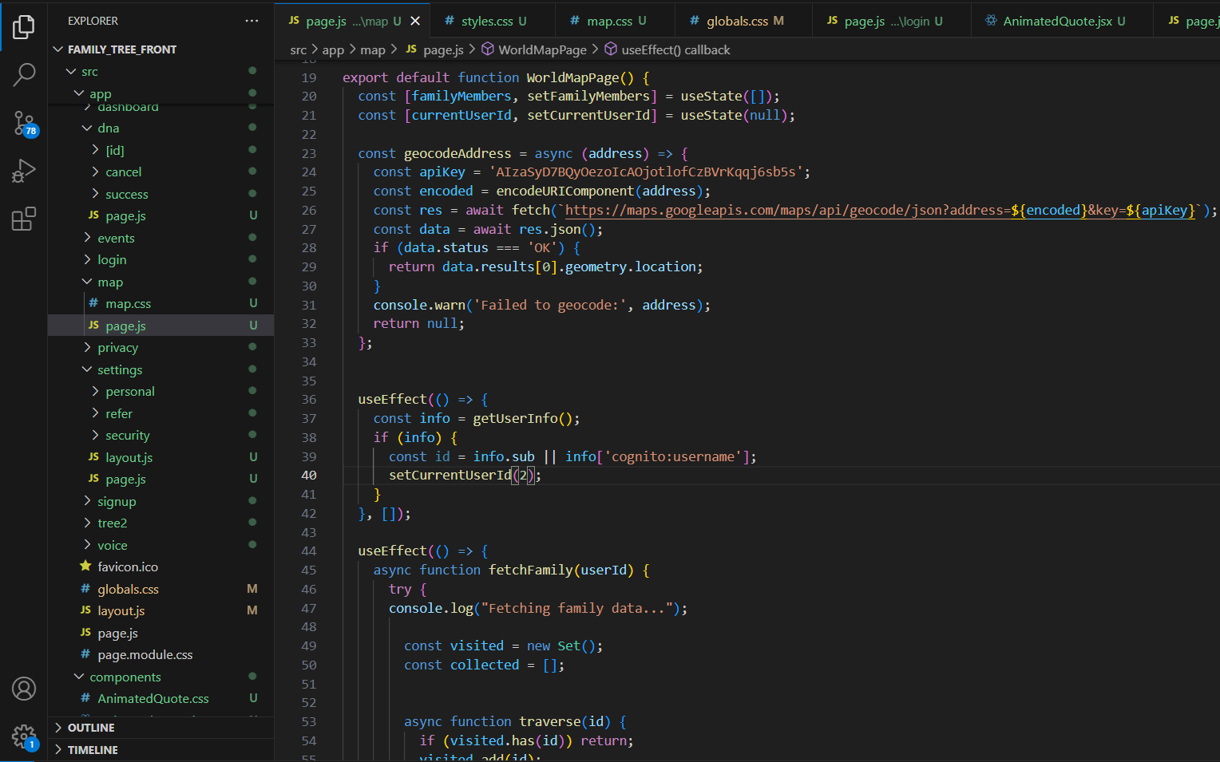

*Figure 11 : Code screenshot of Map Visualisation*

The above snippet WorldMap section works by making use of the Google Maps API to load up all the member of the family details and addresses. This part of the code goes through every member and passes the deal’s data to a helper, which changes it from a name to a position on the map. That way, it won’t have to ask twice in order to see those effects. After collecting all the coordinates, the aspect lines them up country-wise and puts a point on the primary map in the middle, zoomed in. The members are all given a position where they should be on the map. Putting a marker's role is to identify one particular member country. As soon as one of the markers is chosen, the map opens a dialog box containing the profile information and utilizes the shared API to render a preview image. The zooming in or out of the view on the map is animated with a smooth touch, and it also serves as an optional method for gathering closely situated markers when low levels of zoom are needed.

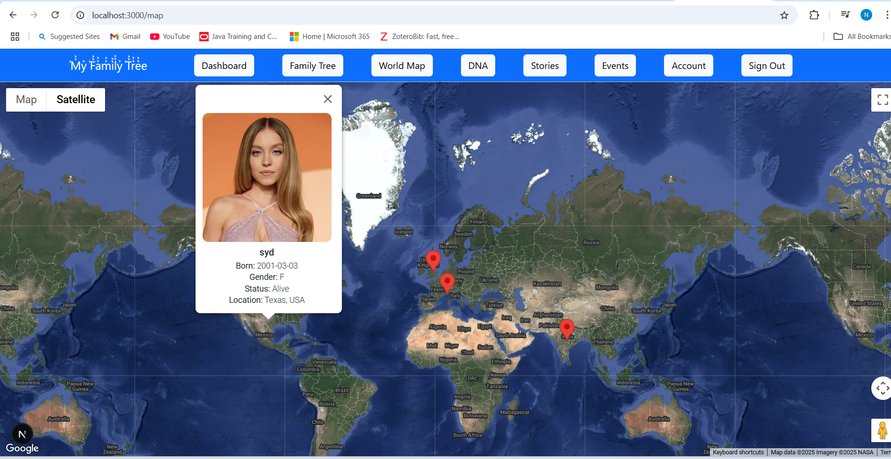

*Figure 12 : Interface of Map Visualisation*

As we can see the figure12 world map displayed with their heritage’s geography here. Every family member’s position is marked by an interactive marker, and you can find profile summaries, birthplaces, or details of migration upon clicking it. The timeline slider makes it possible for users to follow their ancestors by checking which markers occurred in each year. You can use the controls on the map to zoom, move around, change the map style, and have markers grouped for clarity when they’re close together.Markers may be colored by line of descent, generation, or by type of relationship, and search can be done by city, country, or kind of connection. After you apply filters, the placeholder map frame shrinks or expands to make sure all the related contents on the map are still shown.

**6.1.4 DNA Kit Management Snippet**

A click on on the "Buy Now" button sends a request to Stripe to installation a checkout with the picked package and the consumer`s details. After the front-give up redirects the consumer to Stripe, Stripe directs them returned to the /dna/fulfillment web page with the wanted statistics as soon as price is complete. As quickly because the web page is reached for fulfillment, the app gathers the price statistics and thank you the client. A PDF receipt with the client`s statistics is likewise created as a part of bill generation. A consumer can pick out to click on “Download Receipt” to retrieve the bill, after which select “Back to Dashboard” to visit their predominant web page. In addition, the order facts is introduced to the database to permit the dashboard to show it as a latest buy of a package. To preserve the shopping procedure smoother and greater obvious, managing errors, load states, and analytics are included alongside every step.

The below figure13 is a part of DNA in dna/page.js, the handleUpload function is employed to manage asynchronous file uploads by handling input selections, providing feedback for success or failure, and updating the upload indicator. The HTML section of the code reveals the presence of a header, a "Back to Dashboard" button created using React Router, and a grid created using Tailwind utility classes for displaying DNA kits. This way, the process is easy for the users to upload content, and marketplace settings adapt appropriately and can be preserved.

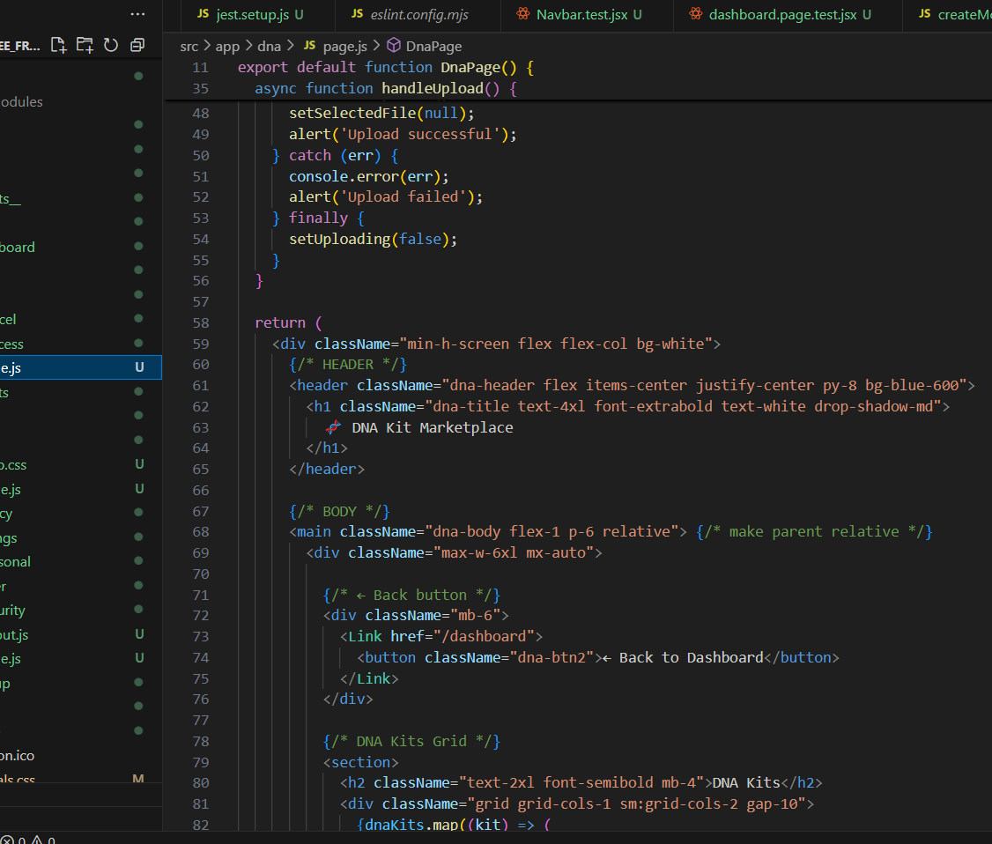

*Figure 13 : Code snippet of DNA Marketplace*

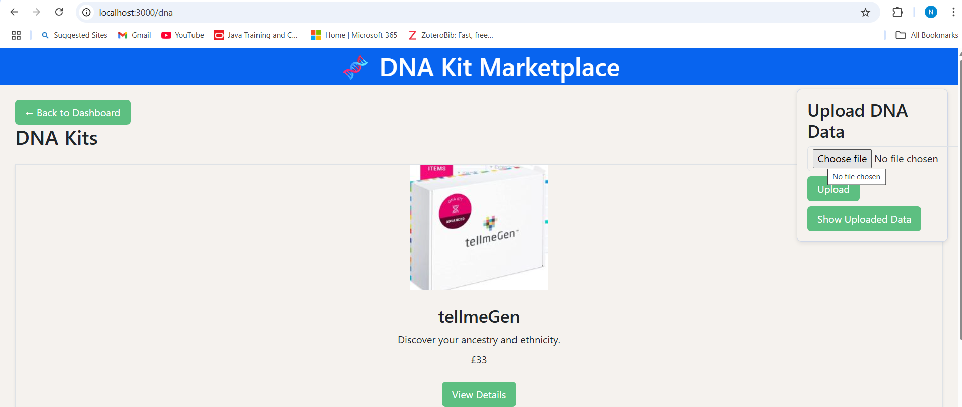

*Figure 13.1 : UI of DNA Page*

Using the upload DNA data panel, users can easily choose and send their genetic data files with a single click. As users complete the process, success indicators and alerts give them feedback instantly. Uploads are listed with all the necessary information, so users can easily pick, download, or delete previous uploads without difficulty. It smoothly includes genetic findings into family accounts, making sure users are in control of their information.

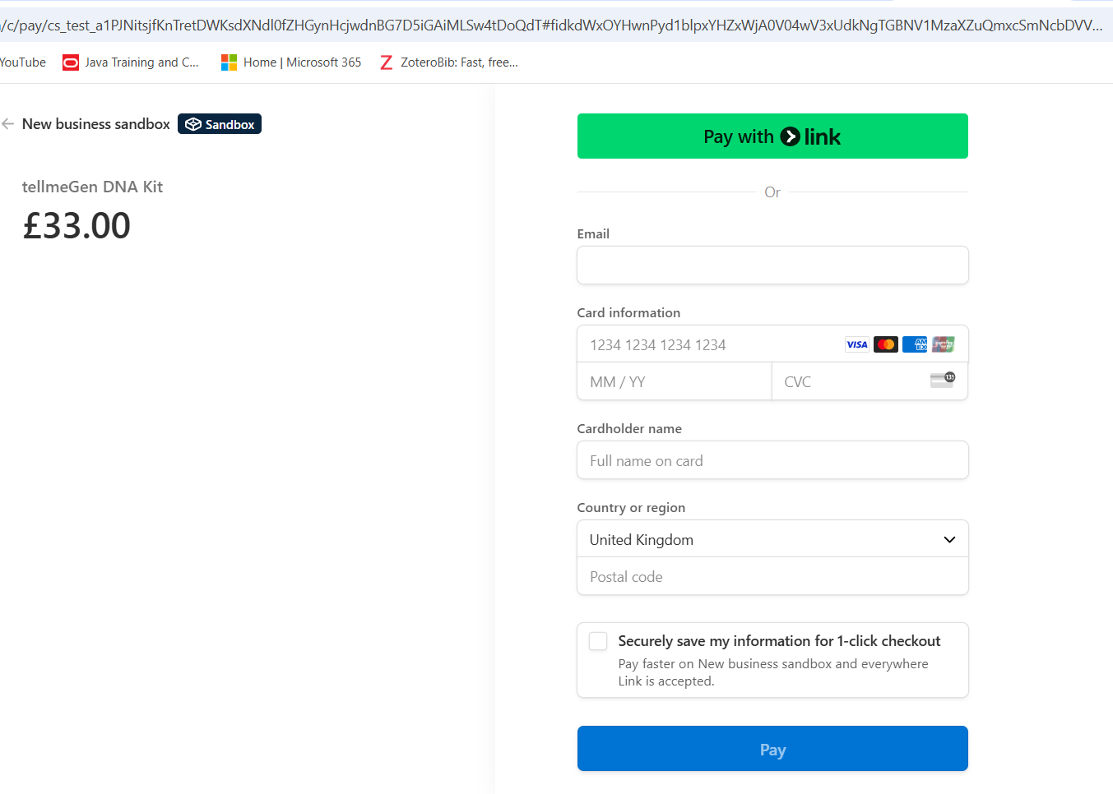

*Figure 14 : UI of Payment Page*

The above figure shows Invoking Stripe's checkout.sessions.create API is the first step using the kit ID, price, and customer metadata for the kit. The user is then sent back to Stripe's secure website, so the card can be pulled and re-checked for payment. Once payment is confirmed, Stripe returns a session ID to the user and the data can be verified by the application on the front end using stripe.checkout. The app finishes off by holding an order ready with the invoice and sending a confirmation with a download receipt, pushing the user on to their dashboard again.

**6.1.5 Voice Stories Snippets**

Users can record their voice back-to-back by using an in-browser function. Clicking "Record" will call the startRecording function, which launches the recorder and grabs the data chunks by watching for them with recorder.ondataavailable. Once you say "Stop" and the recorder.onstop event is fired, your function handleUpload takes the merged chunks, adds it to a FormData object, and POSTS the data to /api/voice-stories. Once the story is uploaded successfully, it is posted to the state and shown right away in the list, and any problems encountered during upload are shown in a red alert. This design allows the UI to work well and be easy to maintain. Thanks to the playback, delete, and rename features next to every story on the list, users are able to manage their audio memories freely.

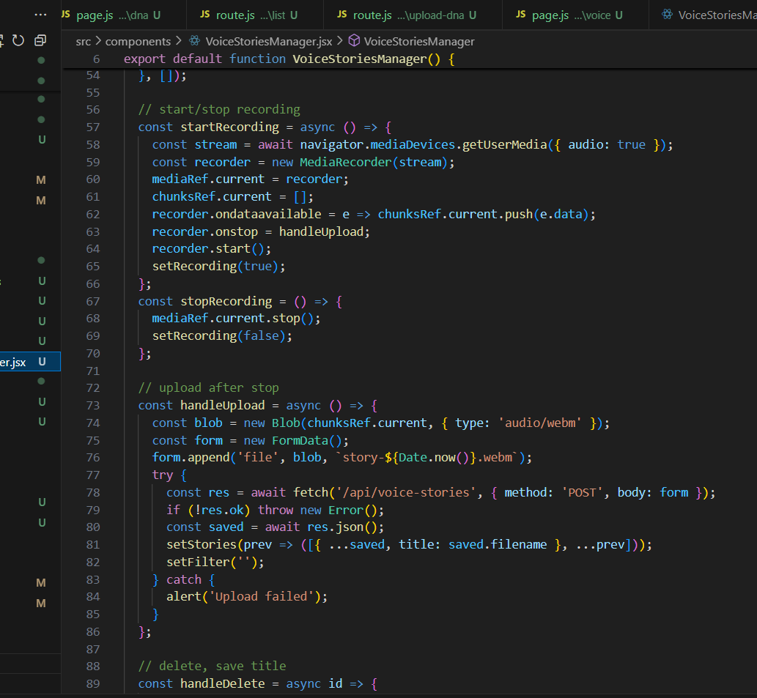

*Figure 14 .1: Code snippet of Voice Stories*

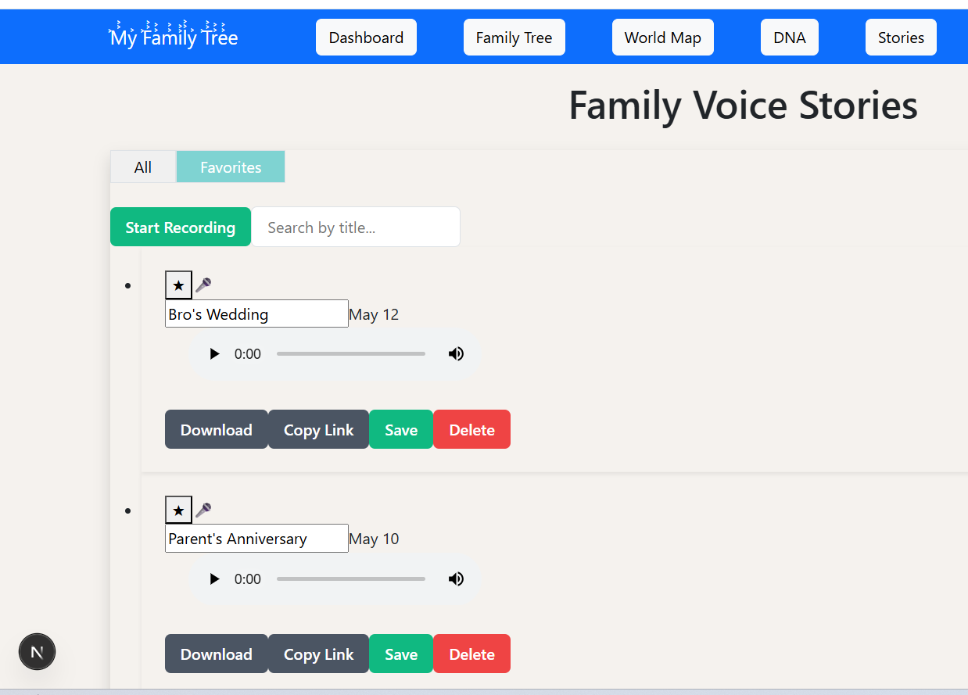

*Figure 14.2 : UI of Voice Stories Page*

This app allows users to easily switch between having all their recordings and the ones they saved as favorites using tabs. A "Start Recording" button can be seen first, and the search bar finds clips by their name as soon as you type. Every entry shows the date it was added, offers a fast way to add it to your favorites and change the name, and has an audio player so you can play audio right there. Under every player, you can easily control the Download, Copy Link, Save, and Delete actions of your recordings. You can easily modify the demo clip order using drag-and-drop and check how uploads of new clips are progressing through progress bars. You can filter items by their date or length, and the layout can be changed between a grid and a list. Because of contextual tooltips and inline help, even users who have never used stories will learn and start using them without difficulty. The device has simple and accessible design and still offers complex ways to save and organize family memories.

**6.1.6 Family Events Snippets**

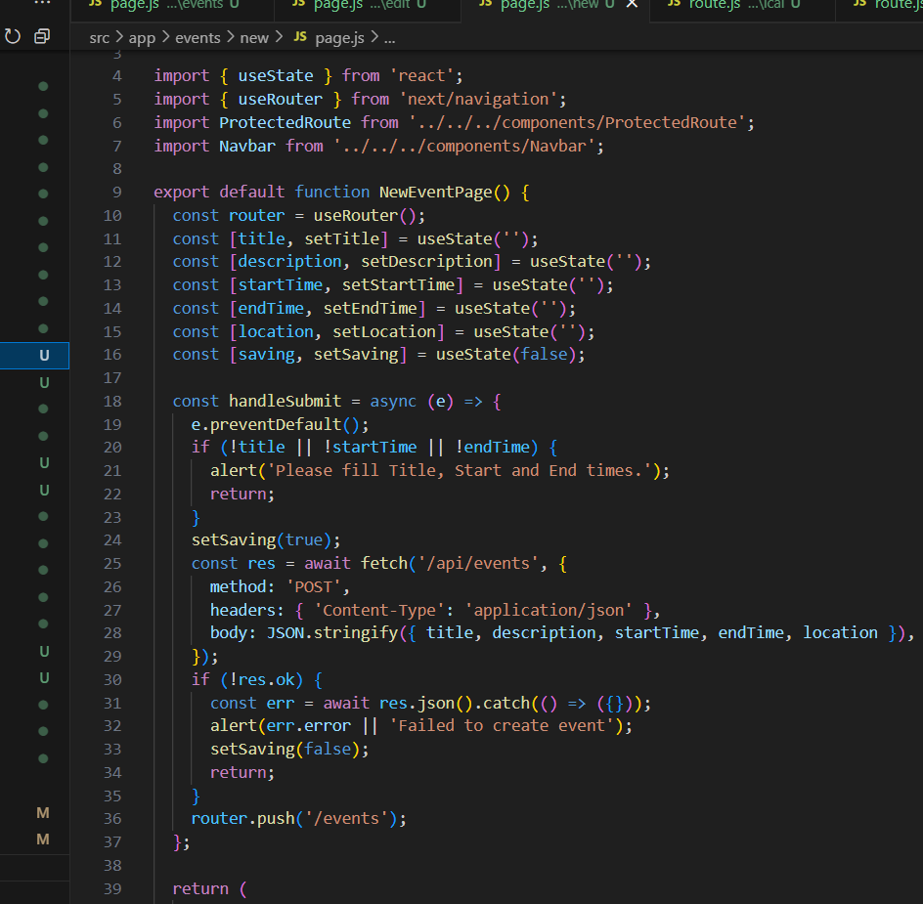

*Figure 15 : Code snippet of Family Events*

All your important life events can be organized and followed by using the same user interface in Family Events, including titles, descriptions, date and time, and location for your events. Once you input them, all your events fall under All, Upcoming, and Past, and you can see your upcoming and past events at a glance. You can modify events on the client, off the given form, and send the modifications to the server instantly as a PUT request so that the new information show up on the screen as fast as possible. Deletion occurs using a confirmation modal, and the API delete call occurs after successful confirmation. The users are supported with date-time checkup and progress indicator while adding or modifying an event, and find flags in the form of badges to search through all the event types. The operations allow for easy planning and monitoring of events within a family.

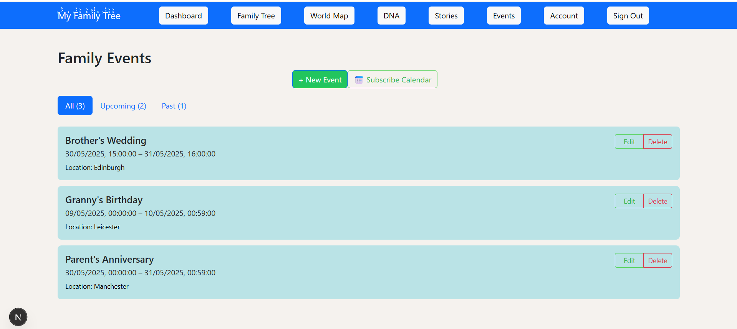

*Figure 16 : UI of Family Events*

All past, present, and future family events are shown on the Family Events tabbed list, which updates itself as you switch between them. You can see events as cards with their title, date/time, and a brief description along with colored status badges. Clicking on the Inline Delete or Edit icon gives visitors the ability to update or delete events easily on the site. Next to every event, there is a button to download information and a section where you can share the event with others. A search field at the top allows you to arrange the calendar by keyword or date, and long lists are broken up with pagination buttons. Real-time validation messages guide users while creating or editing events to enter the right data and have a smooth time using the platform.

## 

## **6.2 Backend Development**

The backend framework for the current project is built using Spring Boot, which supports the business logic, API endpoints, and data exchange between the frontend interface and the database. The framework supports modular services for Authentication, Family Tree Management, Event Logging, and Voice Upload Management. Secure authentication, media repository functionality, relationship management through graph structures, and geospatial mapping functionality are provided through the integration of AWS Cognito, S3, Neo4j, and the Google Maps API. Each service is RESTful and handles HTTP requests coming from the React frontend via Axios. This systematic backend framework provides improved scalability, strong performance, and effective server-client communication.

**6.2.1 System Architecture Overview**

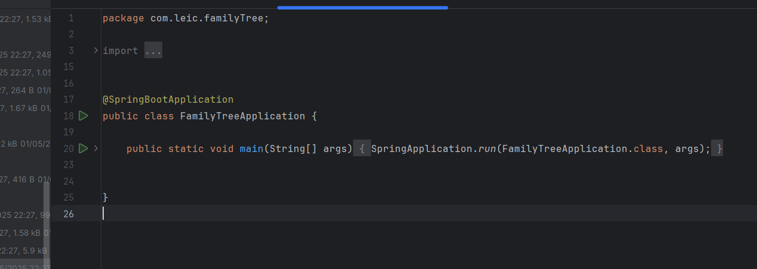

*Figure 17: Backend Main Application*

The backend includes 4 separate layers that permit the carrier to paintings easily   
and dependably. Annotating the FamilyTreeApplication.java magnificence using @SpringBootApplication permits the whole Spring context to begin up and test for beans to installation the application (e.g., S3Config, SecurityConfig), consist of the controller, services, and repositories. The config lessons consist of outside clients (together with the S3 client) and the JWT authentication clear out out chain; meanwhile, controllers create short REST endpoints for customers and events. Service lessons paintings in the back of each endpoint to deal with the enterprise common sense of every transaction, updating connections, permitting the add of files, and checking events, making all this paintings constant and smooth to test. The patience layer relies on Spring Data Neo4j repositories to keep the User area greatness as nodes and their relations as relationships within the graph, and to easily access such relationships. With a layered structure, there is a clear separation between tiers, so unit testing and integration testing are honest and it is straightforward to exchange or substitute any tier with itself.

**6.2.2 Configuration & Security**

The below figure describes SecurityConfig and S3Config classes define the basic components for our backend's configuration and security architecture. In the S3Config class, AWS credentials, such as the access key, secret, and region, are loaded from environment-specific properties files or an encrypted vault, and then use them to create a singleton bean for S3Client for consistent file upload and download through uniformly configured clients. Then, the SecurityConfig class secures every REST endpoint by using a security filter chain that enforces CORS policies (restriciting origins to given domains), requires JWT authentication, and automatically checks for tokens presented by our identity provider. By externalizing sensitive data to application.yml (or environment variables) and using Spring’s @Value injection, we negate the threat of exposing confidential data in source control and make changing environments easier between development, tests, and production. This integrated approach allows for both secure media repository and complete API protection, thus avoiding the scattering of credentials within the codebase.

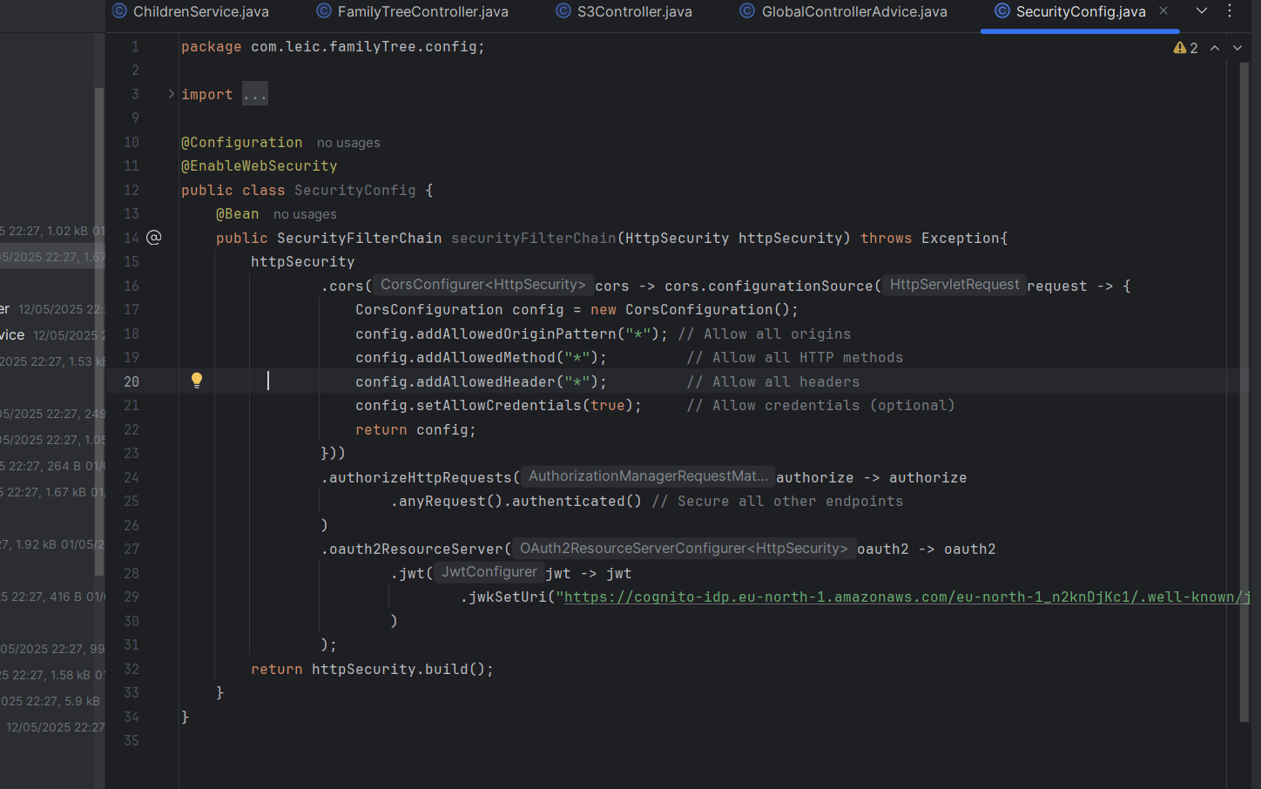

*Figure 17.1: Backend Configuration Security*

**6.2.3 Controller Layer**

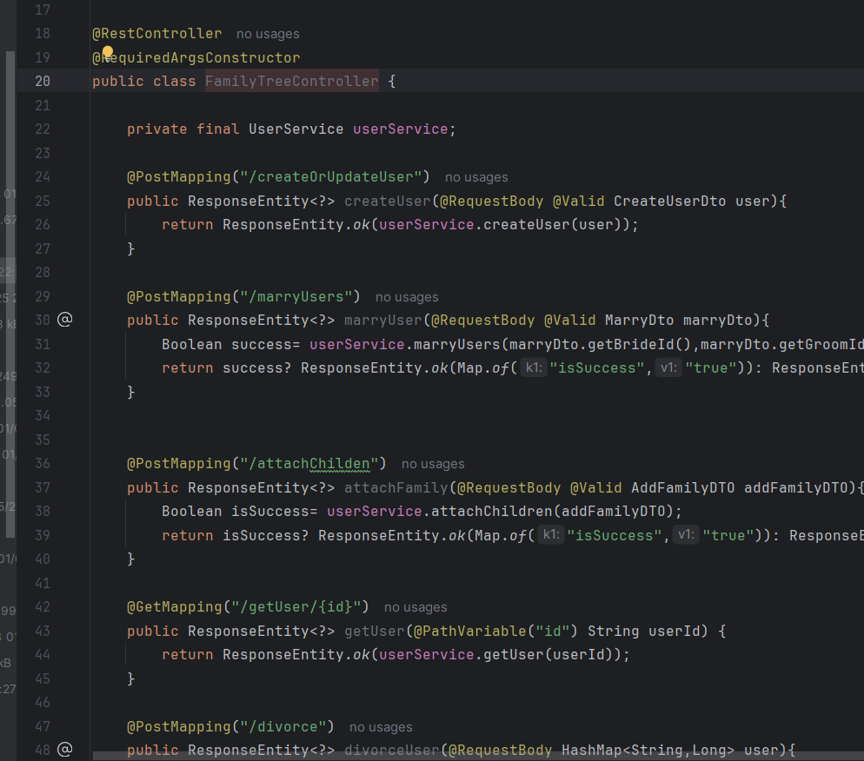

*Figure 17.2: Code snippet of REST endpoints*

The Controller layer is in charge of establishing a clear set of REST API routes for the application to use. The FamilyTreeController is used for user records and relationships, and provides endpoints like /createOrUpdateUser, /marryUsers, /attachChildren, and /getUser/{id}, which are set up to deal with carefully designed DTOs and convert tree updates to JSON. S3Controller includes endpoints, such as /upload-profile and /download-profile/{userId}, that are dedicated to uploading and downloading profile images with security helped by AWS S3. For family milestones, the EventsController follows the CRUD structure of GET /api/events, POST /api/events, PUT /api/events/{id}, and DELETE /api/events/{id} to provide a dependable way to manage events. All in all, they do the validating, call specific business logic, and form the appropriate HTTP response, clearly separating only the API functions from actual business rules.

**6.2.4 Service Layer**

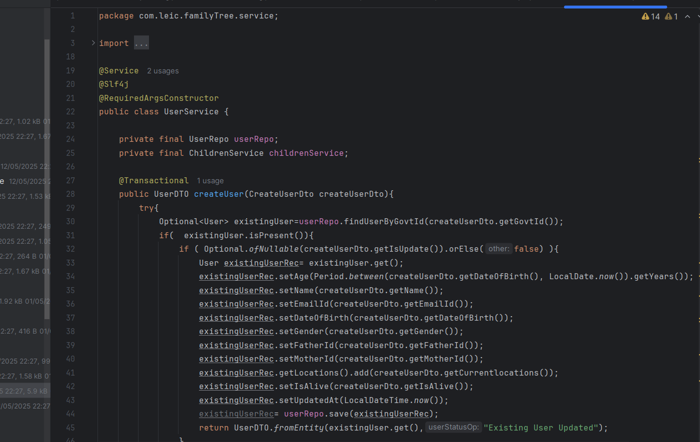

*Figure 18: Code snippet of Service Layer*

The Service Layer works to buffer the interaction between controllers and the persistence layer, while also making sure business rules are correctly applied and data is securely maintained within transaction boundaries. So, the UserService uses @Transactional to ensure if any issues such as using invalid user identifiers or database complications occur, all changes are reversed. As in the previous example, the ChildrenService sees to it that parent-child relationships do not include cycles and treat all changes as complete and inalterable. At the same time, the uploading and downloading of profile images use separate methods that retry as needed and translate SDK errors to meaningful messages for the domain. As a result of using services for the logic, the application achieves a clean separation between different concerns. Using controllers for requests, services for rules, and repositories only for accessing data leads to a codebase that can be tested, maintained, and extended better.

**6.2.5 Persistence & Entities:**

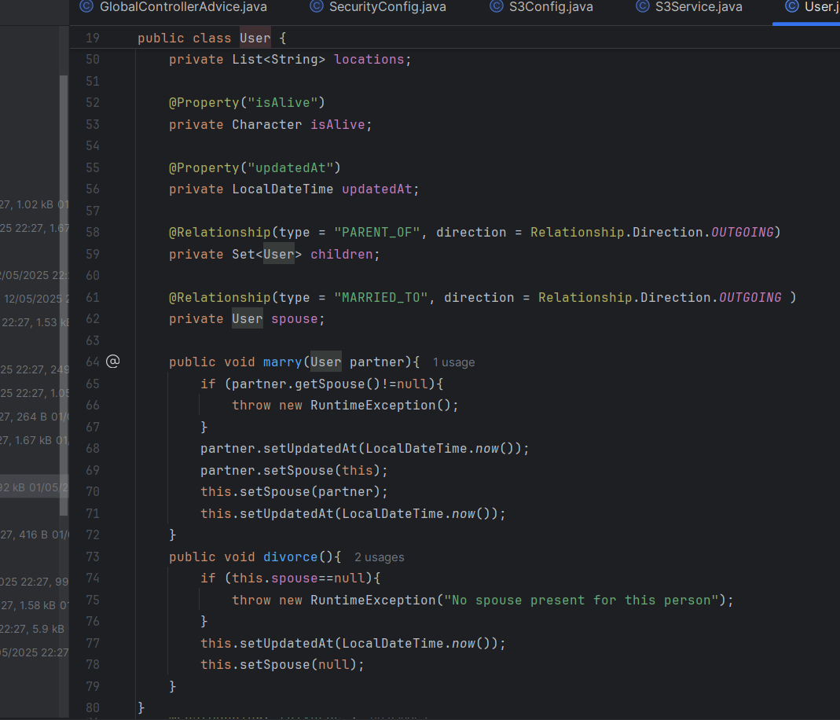

*Figure 19: Code snippet of User Entities*

The Spring Data Neo4j repository feature maps my object classes as graph nodes and relationships, allowing for easy access to family members. By marking User as a Node and adding @Relationship for children and spouse, you can easily search through related data using Neo4j. These DTOs act as a connection between the JSON sent by the Scheduler, and the domain models, enforcing validation before the data is saved in the database. With the data pulled into an interface (UserRepo extends Neo4jRepository<User, Long>) and the interface assigned, the application gets built-in support for CRUD operations and can customize queries. It ensures that each piece of entity logic is separate from business rules and the API, making it easier to maintain and type-safe.

**6.2.6 Routes And Functions**

|  |  |  |
| --- | --- | --- |
| **Method** | **Route** | **Description** |
| GET | /api/getUser/{id} | Fetch a user and all the immediate people they are linked to. |
| POST | /api/createOrUpdateUser | If the user exists, update their node data using the new profile information, or add the user information as a node. |
| POST | /api/marryUsers | Bring two existing users together and form a spousal relationship for them. |
| POST | /api/attachChildren | Connect some or all children to the desired parent (or parents) |
| POST | /api/divorce | Disconnect the relationship of marriage that binds the users. |
| POST | |  | | --- | |  |  |  | | --- | | /api/upload-profile | | Store the uploaded profile image in the S3 storage system. |
| GET | |  | | --- | |  |  |  | | --- | | /api/download-profile/{userId} | | Return the S3-stored profile image for the user ID in question. |

## 

## **6.3 API Integration**

The use of external APIs enables various core operations by offloading complex functionalities to expert service providers.AWS Cognito handles all of the OAuth2 authentication flows and session management, effectively eliminating most credential-related logic from our code.Google Maps, Places, and Geocoding APIs power interactive world maps, location autocomplete, and coordinate lookup.The Stripe Checkout API enables secure purchases for DNA kits through redirecting users to a hosted payment page and effectively returning receipts.

**6.31 AWS Cognito Identity Provider**

The Cognito Identity Provider acts as a secure user management framework, enabling the delivery of OAuth2 tokens and managing session states without storing user credentials on our servers. In the file login/page.js, we construct a Cognito authentication URL based on the client ID, redirect URI, and desired scopes, then redirect users to sign in or register via Cognito’s hosted user interface. After successful authentication, Cognito redirects users back to our Redirect component, which intercepts the incoming authorization code and trades it for both an ID token and access token using the /oauth2/token API. The resulting tokens are stored securely in HTTP-only cookies or held in memory, later appended to subsequent API requests for retrieving user details. On each protected page render, ProtectedRoute checks the signature and validity of the token against the JSON Web Key Set provided by Cognito, thus ensuring that only authenticated sessions have access to sensitive routes. By offloading the sign-in experience and token validation responsibilities to Cognito, we follow best-practice security guidelines, simplify password management, and easily incorporate Single Sign-On capabilities across our application.

**6.32The Google Geocoding API**

The Google Geocoding API enables the retrieval of geometric location coordinates for any given address through a simple request protocol. When a location is entered, be it within a dialog or within the mapping interface, our frontend application sends a GET request for the query against the Geocoding endpoint using our secure API key. The API sends us a response object in the form of received data in JSON, within which each record contains detailed and accurate geometric data, from which the latitude and longitude values for our primary entry are extracted. For purposes of reducing latency and preserving resources, we store successfully geocoded responses within the application state, thus enabling follow-up requests for the same addresses to leverage the cached data. When we are unable to get records from the API or when the rate limit is exceeded, we show users a notice inviting them to come back and enter different search phrases. After validating the coordinates, we strategically place and arrange InfoWindow locations, thus improving the mapping experience to be user-focused and real-timed. The interaction between these systems improves spatial location management and supports the intuitive nature of the mapping feature embedded within our application.

**6.33 Stripe Checkout API**

It removes the complexity of managing payments by letting you open a regulated hosted payment page just by making one Stripe API request.After someone clicks on “Buy Kit,” stripe.checkout.sessions.create is used by our back end to add the kit’s price and currency, as well as the chosen success and cancel URLs.Stripe generates a session identifier which the front end uses to take the user to the Stripe Checkout page.Users need to put in their payment card details and pass through any security checks, if required. All compliance and verification tasks are handled by Stripe.When the payment is done, Stripe automatically navigates to the URL we have set as a success URL and sends them the required Session ID.To know the status of the payment and to get the required payment_intent details, the app uses the function stripe.checkout.sessions.retrieve.As soon as the order is confirmed, a PDF invoice is generated that you can download. Once the user checks out, they see the purchase confirmed on their dashboard, and a secure receipt is sent to them by email.

## 

## **6.4 Plugins and Libraries**

|  |  |
| --- | --- |
| **Name** | **Description** |
| next | Supports routing features with files, rendering on the server side, and API features. |
| react | Supports routing features with files, rendering on the server side, and API features. |
| stripe/stripe-js | The Stripe JavaScript SDK helps developers resolve payment issues by giving them the ability to drive users to a checkout session. |
| amazon-cognito-identity-js | AWS JavaScript SDK module for integrating Cognito OAuth2 flows, token acquisition, and consultation management. |
| aws-sdk/client-s3 | The back end uses the AWS SDK v3 client for S3 to upload and retrieve media files, including profile pictures. |
| neo4j-java-driver | The official Java driver for managing connections to the Neo4j graph database and running custom Cypher queries. |
| axios | Client for making HTTP requests to APIs. |
| pdfkit | dynamically generates PDF files that are helpful for producing documents and reports. |
| clsx | A small tool for conditionally combining CSS class names that simplifies JSX dynamic styling. |

## **6.5 Build and Run the application**

**1. Run Spring Boot Backend**

* Open the terminal and navigate to the backend .jar file directory.
* Execute the following command to start the Spring Boot application.

“java -jar filename.jar”

* Wait until you see: “Started Application in X seconds”.
* This confirms the backend is running typically on <http://localhost:8080>.

**2. Connect Neo4j Database :**

* Open Neo4j Desktop or Browser <http://localhost:7474>.
* Open Neo4j and create a new database called FamilyTree with a password 12345678. The password and the database name has been fixed as the application is being run with the jar file to avoid other complexities.
* Ensure the database is running.
* You should see graph nodes if data is already inserted.
* Double check in backend server application.properties.

**3. Start Frontend in VS Code :**

* Open the frontend project folder (family_tree_front) in VS Code.
* Open the terminal (Ctrl + `) and run: “npm install”.
* Once all dependencies installed then run : “npm run dev”.
* The frontend will be available at: http://localhost:3000

# Testing

The testing process forms an imperative component of system development, maintaining the dependability, security, and overall operating effectiveness of the application. It enables immediate detection and correction of bugs, thus ensuring the application is consistent with the requirements of users and working optimally in different contexts. Without proper testing, systems are prone to security exploits and breakages, leading to a poor user experience and data loss. A complete set of test cases was carried out, involving unit tests, functional tests, integration tests, and security tests to determine the resilience and reliability of the web application. The tests ensured that individual features functioned as expected, the system as a whole showed satisfactory behavior, integration between different modules was done seamlessly, and users' data was protected during operations. Postman was an important tool used to determine back-end features, which included API tests, and also ensured security and functionality within the application through different layers.

**7.1 Unit Testing**

Unit tests were performed on separate frontend pieces using Jest together with the React Testing Library. Every feature, including the Navbar, Dashboard widgets, and DNA Kit submission forms, was tested individually to confirm component rendering and the respective user interface behavior. Button clicks, API requests enabled through Axios, and state changes were tested separately. On the server side, the business logic inside the service layer was tested through purpose-built unit tests within Spring Boot, depending on the implementation under way. This unit testing ensures that the underlying logic is functioning properly before integrating it.

Extra testing coverage was added to include reusable elements like modals, form fields, and notices. API interactions and component attributes were mocked using methodologies to simulate edge cases and error paths. The unit tests allowed for early detection of associated regressions and increased confidence in the stability of the code.

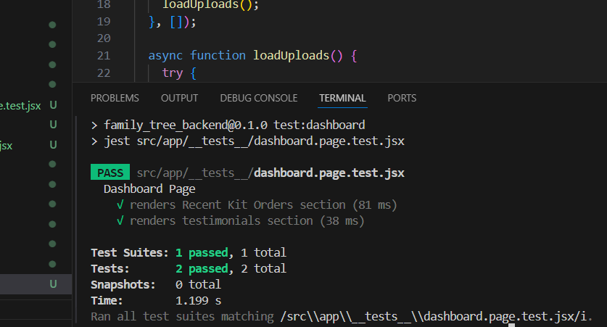

*Figure 20: Snippet of Dashboard Testing Using Jest*

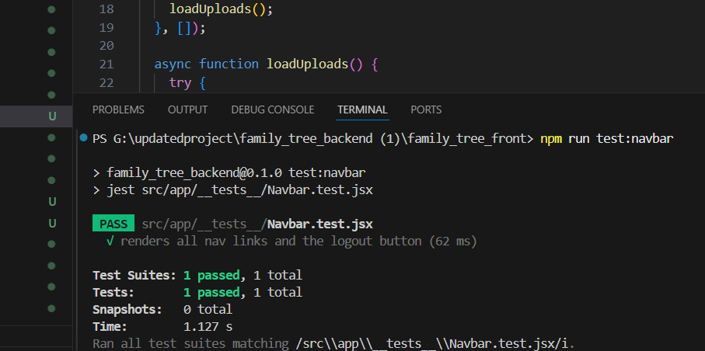

*Figure 21: Snippet of Navbar Testing Using Jest*

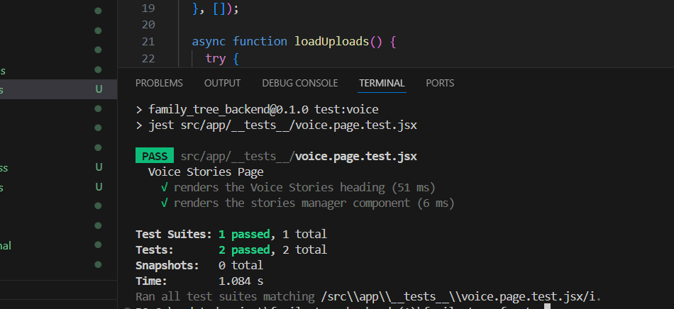

*Figure 22:Snippet of Voice Stories Testing Using Jest*

**7.2 Functional Testing**

Backend testing of the FamilyTree module requires a thorough review of its core API endpoints by means of the tool, Postman. All APIs are crafted with the purpose of handling individual and relational data in the setup of the Neo4j graph database. The GET /GetUser API allows retrieving user-specific details that are relevant in the current context, assuring proper retrieval of the user ID along with related attributes like name, date of birth, and location. In order to determine the reliability of this functionality, valid and invalid identifiers are both tested.

The POST /CreateOrUpdateUser endpoint is used for growing new person debts or updating current ones. During checking out, payloads withinside the shape of JSON with all required fields are passed, and the related reaction codes like 201 Created or two hundred OK are confirmed for correctness. Similarly, the POST /MarryUsers endpoint is used for growing relationships of kind MARRIED_TO among person nodes. This calls for passing legitimate person IDs, and Postman is used for making sure that such courting is nicely created withinside the graph and that a a success repute is received.

The API call POST /attachChildren is tested for effectiveness in creating hyperlinks between parent nodes and their respective child nodes through the relationship of PARENT_OF. The testing also includes cases of missing one or both of the parent IDs, in turn testing the sufficiency of error handling abilities. The POST /divorce API is also tested for its operational capability in ending marriages and for determining the resulting changes in the graph. Then, POST /upload-dp is tested for its function in handling profile picture uploads, proper multipart form data handling, and proper interaction with S3 storage platforms. All the APIs are thoroughly tested for boundary values and failure points, ensuring that the backend processing of input is both secure and efficient.

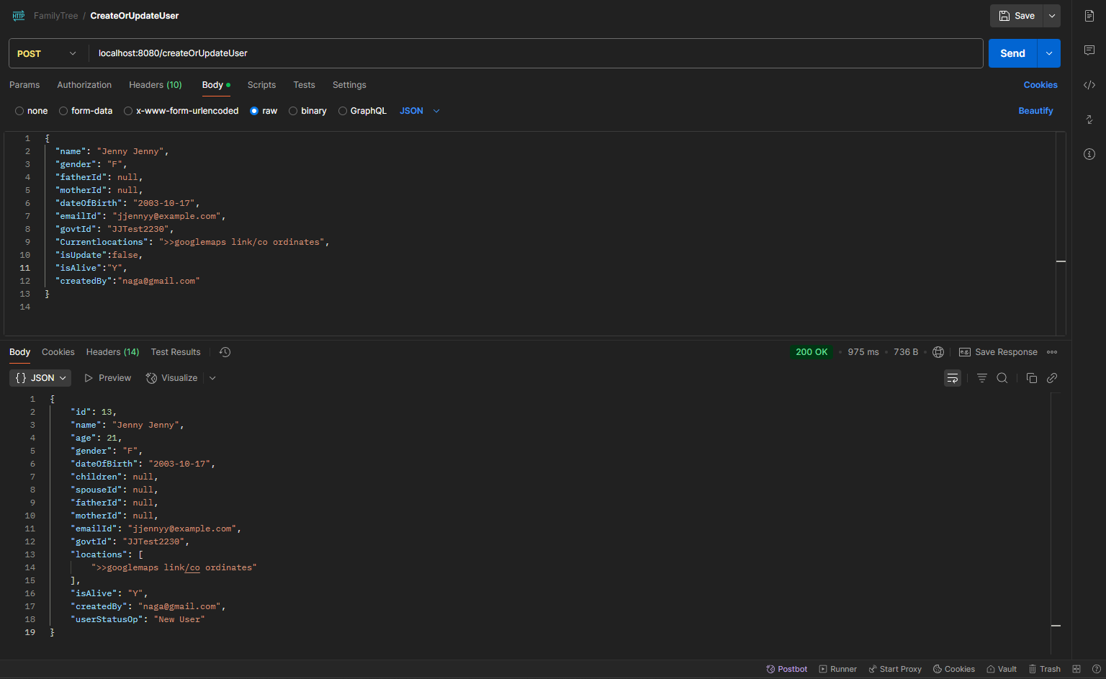

*Figure 23:Testing /createOrUpdateUser API*

**Failure case:** If an authorised user tries to access the API, with an improper request structure (example - without a name), the API should respond back with a failure message and code.

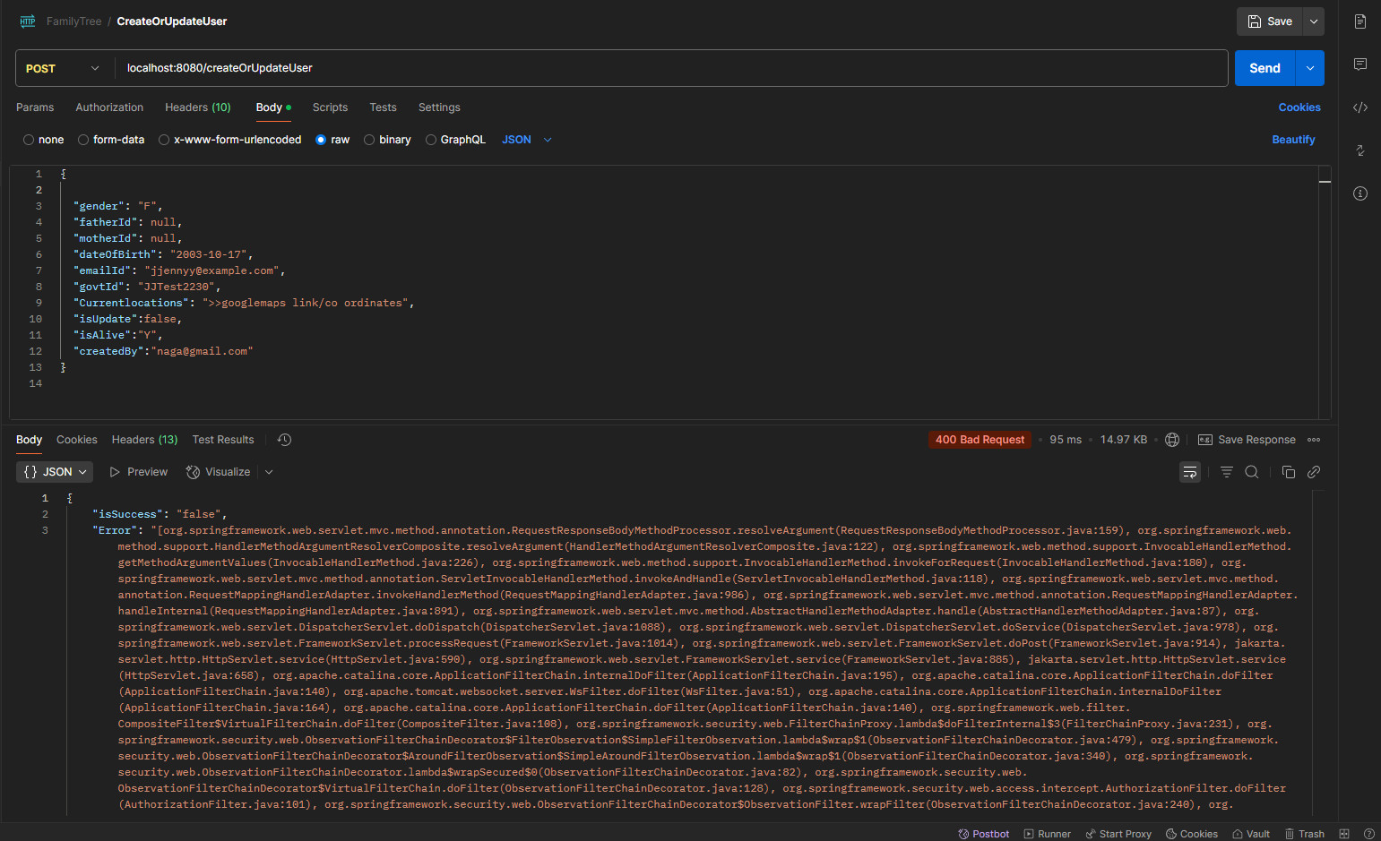

*Figure 24:Testing Failure Case /createOrUpdateUser API*

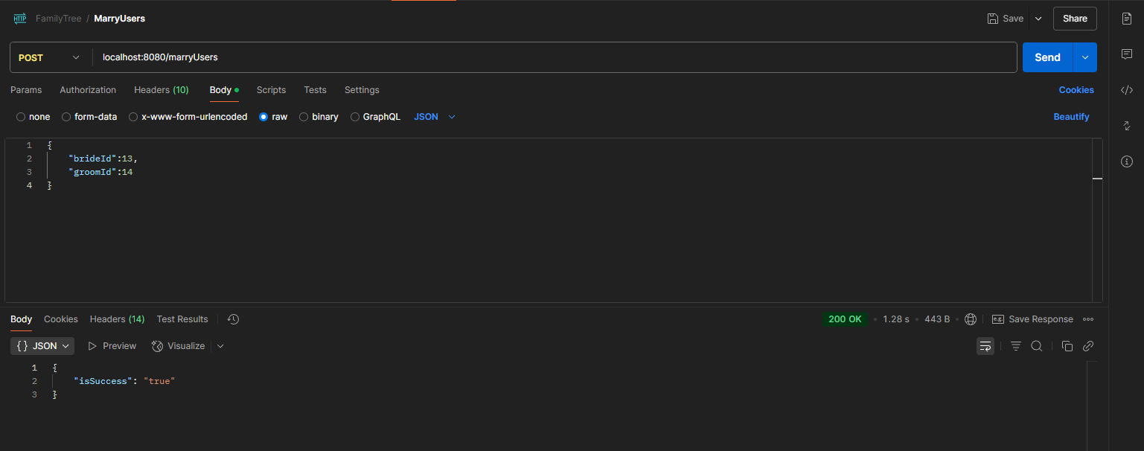  *Figure 25:Testing /marryUsers API*

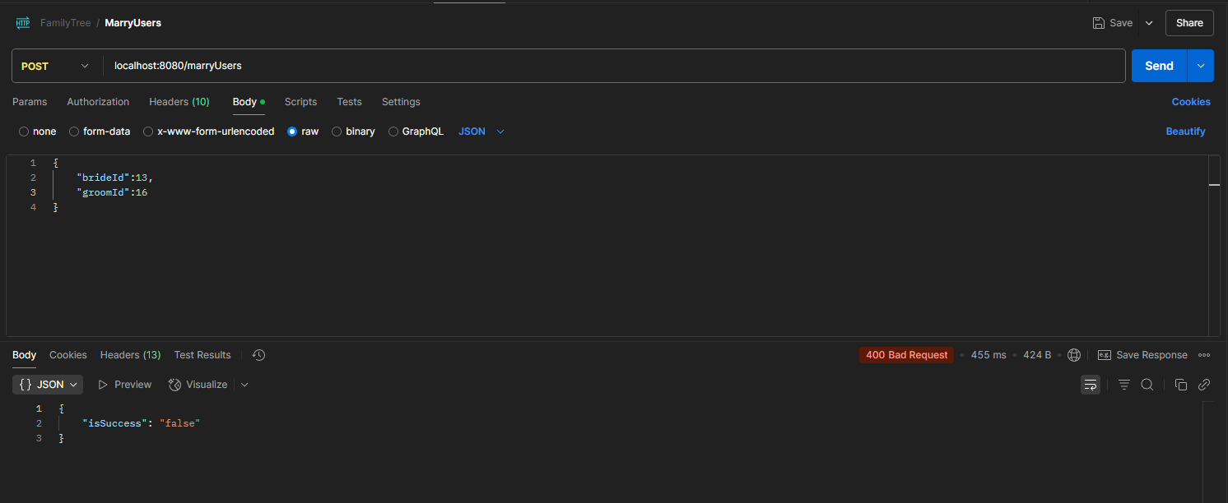

*Figure 26:Testing Failure Case /marryUsers API*

**Failure case:** If any of the user records do not exist or already have a spouse record. The API fails and sends back “isSuccess” as false.

**7.3 Integration Testing**

The integration testing enabled smooth communication between the frontend and backend modules. In this process, Postman was used to simulate real API workflows, including user authentication, family tree expansion, and uploads, while communicating with the real Neo4j database. Similarly, the frontend React components were integrated with the actual backend via Axios, allowing integrated tests to ensure the validity of request-response cycles. For example, the family tree visualization was dynamically updated in sync with the backend. This process ensured system integrity across different services and APIs.

**7.4 Security Testing**

The primary focus of security testing was safeguarding essential functions like data retrieval, token verification, and login. AWS Cognito was utilized for secure authentication, and Postman was used to simulate protected API requests with and without legitimate JWTs. This assisted in verifying that endpoints such as /member and /kit/order were inaccessible to unauthorized users. Tests at the client verified that protected routes, like /settings, were only accessible by authenticated users. To further avoid the system being vulnerable to common security threats, a thorough examination of input sanitizing, Cross-Origin Resource Sharing (CORS) headers, and error-handling techniques was carried out.



*Figure 27: Kit Order Receipt*

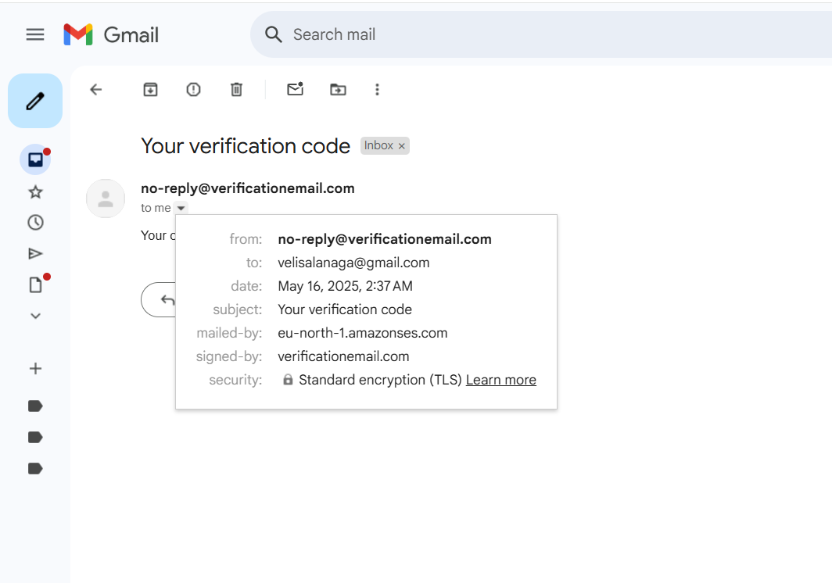

*Figure 28: OTP Verification for new user*

# 8. Future Enhancements

Planned future development for this project includes improving the functional depth and the scalability of the application. A significant addition would be the real-time collaboration where several users can edit and update family trees in real time using WebSockets or Firebase. Multilingualism is also in the pipeline, which will make the application more accessible to users across the world. On the server side, relationship predictions and duplicate identification can be done based on user traits and metadata using AI-powered machine learning algorithms. Recommendation engine for purchasing DNA kits based on the family health history can also be contemplated. For improved visual representation, interactive 3D tree structures using libraries such as D3.js or Three.js will improve usability. Security can be improved by adding biometric login or two-factor authentication. Finally, deployment on Kubernetes via CI/CD pipelines will provide easy scaling and production maintenance. In a bid to further enhance the user experience, a mobile app version of the platform may be created using React Native to allow easy access on devices. A significant enhancement would be the incorporation of voice-to-text features for older users to dictate stories directly into the system. Integration of genetic health predictions in third-party genomics APIs can also render the DNA module medically applicable. Further, adding more search filters and timeline visualizations will allow users to seamlessly move between generations and historical events. These enhancements will render the system smarter, more holistic, and real-world deployable at scale.

**9 . Summary**

This project has been concluded with meeting all of the required criterions, touching down upon a few of the recommended criterions and a few of the desired criterions.This project is currently fully functional allowing users to create their own profiles. Along with this, users can create their personal family tree which is stored within the database in the backend which allows the timely retrieval of the user data. Data privacy and user privacy is respected with the usage of AWS Cognito for user management and the usage of a secured Neo4J database to handle all family tree related data. Alongside that, the implementation of map view within a family tree application has introduced a new feature within this application which has not been seen in any other application currently being used by others in the market. The frontend of the application runs efficiently for rendering the family tree. This was an issue itself from the very beginning of the project to ensure that the family tree can be rendered safely and smoothly without crashing the application which has successfully been implemented with custom defined functions ensuring peak performance under heavy load. This has also ensured that users with a huge amount of data can load their family trees smoothly.

Another aspect of this project was to ensure that duplicate data is optimised and managed. With the current solution of implementing a graph database ensuring strict graph linkage based upon government ID, has essentially made sure that duplicate data is not an issue anymore in this application. Another key aspect of this application was to ensure collaborative usage of this application which has also been successfully implemented in this application as users can add other family and the users can make their own profiles later on to manage their account.

# 10. Conclusion

To conclude this application development journey and building this application, it should be noted that the application in its current stage is ready to be released to the general public with a few other tweaks added to secure the application. With the current population spike and a world constantly progressing digitally, it is essential for everyone to have a track record of their family. With generations Connect, it is not just about being an application to maintain a family tree, but also an application that users can use to get in touch with their family and stay up to date with all family updates.

Generations Connect as an application is not a replacement of market leading platforms,but it is primarily focuinsg on filling up a gap in the current market which focuses on a family tree application which is feature rich and at the same time free.With the extensive set of features implemented in this application, it is to be noted that the application can also be used for genealogy research being done on any family. With further future developments planned to happen on this application, it will be made more safe, feature enriched and customer focused. The primary goal of keeping the platform free to the wide population base will still remain as a primary focus.

However, in order to make sure that the platform is running smoothly and steadily, implementation of ads will also be considered for this application.A lot of research work was done on family trees and genealogy which has made this project development journey insightful. With the development of this project, it is clear how different user requirements are sufficed through an application building process. Significant amount of challenges were faced during the build phase of this application. Essentially with a common bug of AWS Cognito not working properly with any JavaScript based API due to its outdated helper library, this halted the development procedure for a significant time.Another significant challenge faced during this application development phase was to ensure the efficiency of the frontend application without burning out the backend server with frequent API Calls. This issue was also covered.With its current stage of development and with the future plans laid ahead for this application, it is to be noted that the application can fill the gap currently existing in this category of application.

# 11. References

1. Lachmund, Peter, et al. ‘The Pedigree Tool: Web‐based Visualization of a Family Tree’. *Human Mutation*, vol. 23, no. 2, Feb. 2004, pp. 103–05. *DOI.org (Crossref)*, <https://doi.org/10.1002/humu.10301>.

(The Pedigree Tool is a web application based on Java and PHP that enables the interactive and efficient creation and display of multi-generation family trees in standard pedigree notation (Lachmund et al., 2004).

1. Anetseder, Martin, et al. ‘Provocative Metabolic Testing for Malignant Hyperthermia by Intramuscular Caffeine and Halothane Application in Humans: [2002][A-432]’. *Anesthesiology*, vol. 96, no. Sup 2, Sept. 2002, p. A432. *DOI.org (Crossref)*, <https://doi.org/10.1097/00000542-200209002-00432>.

(The Pedigree Tool is a web application based on Java and PHP that enables the interactive and efficient creation and display of multi-generation family trees in standard pedigree notation (Lachmund et al., 2004).)

1. Tokutomi, Tomoharu, et al. ‘F-treeGC: A Questionnaire-Based Family Tree-Creation Software for Genetic Counseling and Genome Cohort Studies’. *BMC Medical Genetics*, vol. 18, no. 1, Dec. 2017, p. 71. *DOI.org (Crossref)*, <https://doi.org/10.1186/s12881-017-0433-4>.

(Tokutomi et al. (2017) discuss F-treeGC, a simple computer software that relies on questionnaires for creating and presenting detailed trees for families. It is particularly beneficial for large genomes and for genetic counseling.)

1. Andreasen, Nancy C. ‘The Family History Approach to Diagnosis: How Useful Is It?’ *Archives of General Psychiatry*, vol. 43, no. 5, May 1986, p. 421. *DOI.org (Crossref)*, <https://doi.org/10.1001/archpsyc.1986.01800050019002>.

(Andreasen (1986) examines in detail the usefulness of systematic family-history interviews for psychiatric diagnosis.

She asserts that formal family histories make diagnosis more accurate. That said, their utility is usually limited by patients' recall of details and by incomplete or absent family history.)

1. Bokhare, S.F. & Zainon, Wan Mohd Nazmee. (2019). A review on tools and techniques for family tree data visualization. Journal of Theoretical and Applied Information Technology. 97. 121-132.

(They spot recurring trends, like grid displays and interactive web charts. They outline the challenges associated with visualizing large family trees and suggest ways to create more effective and approachable visualization tools.)

1. Nielsen, Jens Jørn. ‘Digital Humanities : Digitalisering Og Dokument’. *Nordisk Tidsskrift for Informationsvidenskab Og Kulturformidling*, vol. 4, no. 3, Mar. 2015, pp. 5–20. *DOI.org (Crossref)*, <https://doi.org/10.7146/ntik.v4i3.25888>.

(Nielsen (2015) analyzed the way traditional documents are digitized, curated, and interpreted in online spaces, critically examining the paradigms and practices of digitization in the humanities.)

1. Borges, José. ‘A Contextual Family Tree Visualization Design’. *Information Visualization*, vol. 18, no. 4, Oct. 2019, pp. 439–54. *DOI.org (Crossref)*, <https://doi.org/10.1177/1473871619845095>.

(In order to enable more exploratory analysis, Borges (2019) proposes a contextual family-tree visualization that overlays pedigree graphs with individual traits (such as life events and geolocations) and time indicators.)

1. Gomes, Cláudia, et al. ‘Genealogy: The Tree Where History Meets Genetics’. *Genealogy*, vol. 5, no. 4, Nov. 2021, p. 98. *DOI.org (Crossref)*, <https://doi.org/10.3390/genealogy5040098>.

(Gomes et al. (2021) consider how our knowledge of specific lineages and wider population histories is expanded by bringing together contemporary genetic data with genealogical records of the past.)

1. Wallace, Susan E., et al. ‘Family Tree and Ancestry Inference: Is There a Need for a “Generational” Consent?’ *BMC Medical Ethics*, vol. 16, no. 1, Dec. 2015, p. 87. *DOI.org (Crossref)*, <https://doi.org/10.1186/s12910-015-0080-2>.

(Wallace et al. (2015) discuss the ethical implications of constructing family trees and determining lineage and question the degree to which persons who are not directly connected to the individual in question should impact the use of shared genetic and genealogical information.)

1. Singh, Shikha, et al. ‘A CASE OF BIPOLAR DISORDER WITH UNIQUE FAMILY TREE’. *INDIAN JOURNAL OF APPLIED RESEARCH*, Feb. 2025, pp. 22–23. *DOI.org (Crossref)*, <https://doi.org/10.36106/ijar/8200961>.

(Singh et al. (2025) report a case of bipolar disorder within a considerably complex multigenerational pedigree with atypical patterns of inheritance and variable clinical expressions. Their study emphasizes the need for detailed family pedigree construction in determining the accurate assessment of risk and individualized treatment planning.)

1. Yoon, Paula W., et al. ‘Research Priorities for Evaluating Family History in the Prevention of Common Chronic Diseases’. *American Journal of Preventive Medicine*, vol. 24, no. 2, Feb. 2003, pp. 128–35. *DOI.org (Crossref)*, <https://doi.org/10.1016/S0749-3797(02)00585-8>.

(Yoon et al. (2003) state that having the same methodology to gather data, having valid instruments to assess risk, and completing the analysis of clinical usefulness are significant in taking family history into account in chronic disease prevention.To aid and avert difficulties, they prefer employing family histories in the process of discovering risk for public health and primary health care.)

1. Andreasen, Nancy C. ‘The Family History Method Using Diagnostic Criteria: Reliability and Validity’. *Archives of General Psychiatry*, vol. 34, no. 10, Oct. 1977, p. 1229. *DOI.org (Crossref)*, <https://doi.org/10.1001/archpsyc.1977.01770220111013>.

(Andreasen (1977) considers whether good and reliable structured interviews for family histories are measured by certain diagnostic criteria. He also considers the extent to which different examiners agree and how well interviews can predict illness.)

1. Attar-Schwartz, Shalhevet, and Mona Khoury-Kassabri. ‘The Moderating Role of Cultural Affiliation in the Link between Emotional Closeness to Grandparents and Adolescent Adjustment Difficulties and Prosocial Behavior.’ *American Journal of Orthopsychiatry*, vol. 86, no. 5, 2016, pp. 564–72. *DOI.org (Crossref)*, <https://doi.org/10.1037/ort0000195>.

(Attar-Schwartz and Khoury-Kassabri (2016) examine the impact that young people's culture has upon their relationships with their grandparents.)

1. Davey, Adam, and Emiko Takagi. ‘Adulthood and Aging in Families’. *Handbook of Marriage and the Family*, edited by Gary W. Peterson and Kevin R. Bush, Springer US, 2013, pp. 377–99. *Springer Link*, <https://doi.org/10.1007/978-1-4614-3987-5_17>.

(Davey and Takagi (2013) integrate concepts of how individuals develop and research on adult life stages. They emphasize how role changes, such as childbearing or retirement, and aging changes influence family relationships.)

1. Brannen, Julia. ‘Cultures of Intergenerational Transmission in Four-Generation Families’. *The Sociological Review*, vol. 54, no. 1, Feb. 2006, pp. 133–54. *DOI.org (Crossref)*, <https://doi.org/10.1111/j.1467-954X.2006.00605.x>.

(Intergenerational transmission of cultural values, stories, and caregiving practices is examined in Brannen (2006) through in-depth, qualitative interviews with British families over four generations.She explains how gender, social class, and institutional contexts shape unique narrative reconstruction, ritual practices, and caregiving behaviors, in turn solidifying familial identity and maintaining continuity over time.)